Summarized Installation Instructions of RegCM4.4.5.9

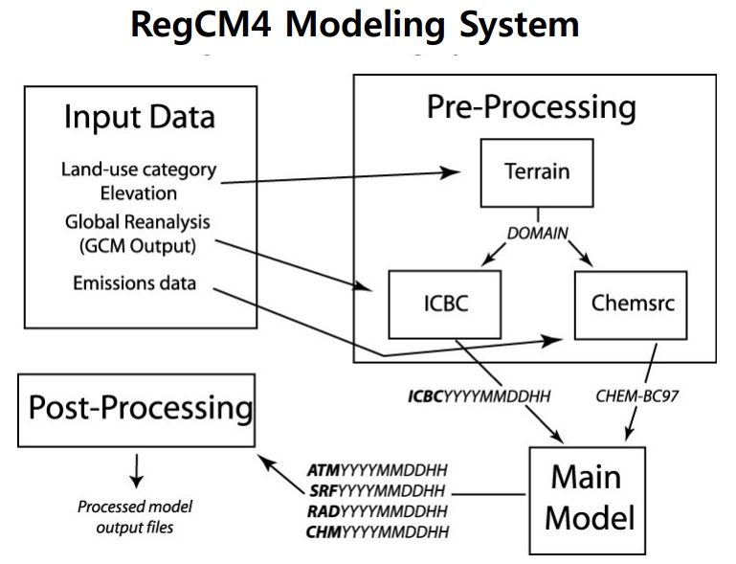
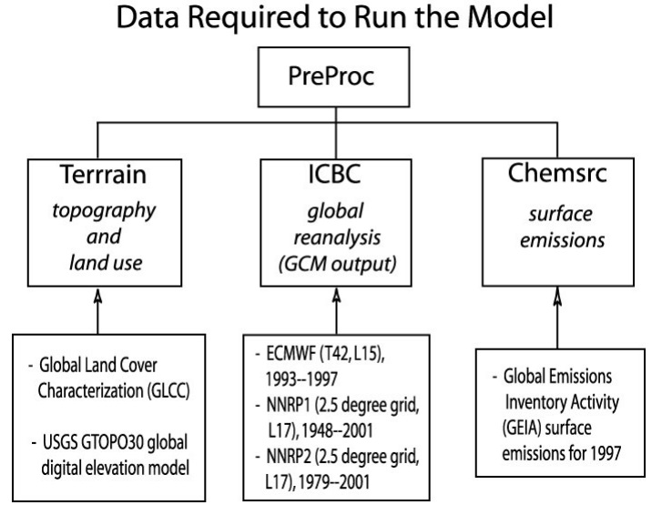
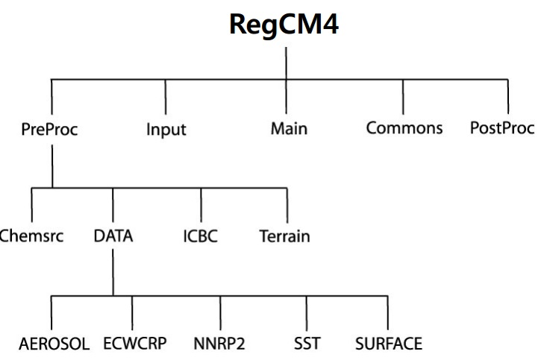
The basic flowcharts

In order to configure and install the RegCM4 model, the following steps are needed:

(Before doing these steps, we need to download of RegCM4 data and then put them inside of the Regdata directory, includes: NNRP1, SST SURFACE, AERGLOB)

Step 1: Requirement Software (connect to internet is needed)
Sudo apt get install soft1 soft2 soft…
Sudo aptitude install DR ghostscript
Sudo aptitude install python gtk2 python glade2
Install of netcdf in the path of: [ /user/local/bin] is needed, so inside of the directory of netcdf, Wright these command respectively:
./configure
Make
Make install

Step 2: Configuration and Installation of RegCM4 (in your desire place)
./configure (sometimes includes, set the path of [netcdf lib] and [netcdf include] and also answer to questions)
Make all
Make install
(After that, we can check green executables files inside of the bin directory of model)

Step 3: Create a new directory outside of directory RegCM4 and using python for making namelist:
For this purpose you should go to "RegCM4/Tools/Scripts" after that, write this commands:
./setup_simulation.py –d /home/pathway of the Regdata –s /home/pathway of the Simulation –n /home/pathway of the Namelist which selected inside this way [/RegCM4/Testing/test_012.in]

If you have a Error massage about the Bin directory, then following command:
Vi setup_simulation.py (you can use any Editor instead of the Vi Editor)
After that, you change the bin instead of the Bin at options of the text

At the end of this step, you should find 4 folders which there is inside simulation directory, includes: bin, input, output, namelist.in

Step 4: Edit or define your objectives inside of the Nimelist which is located inside of the Simulation directory by any Editor:
Vi regcm.in (you can use any Editor instead of the Vi Editor)

At the end of this document is provided an sample of namelist.

Step 5:Preprocessing steps for run of RegCM4:
You should go to /home/…/Simulation directory/ and type following commands respectively:
./Bin/terrain regcm.in
./Bin/sst regcm.in
./Bin/aerosol regcm.in (If it was required with regard to the study object)
./Bin/icbc regcm.in

Notice: During this step, if you had any Errors which is about Netcdf, you should examine the each of your prepared data. Most likely, you need to download them again. After this step, you should go to the path of the Simulation directory which is situated inside of the Input data, for checking the produce data that are cropped from the global data. Then you can use or utilize these produce data for controlling the exact range of you domain via Grads software or any similar program.

Step 6: Running of RegCM4 model
Get in the Simulation directory at first, then just for parallel runs, write following commands:
mpirun –np 4 Bin/regcmMPI regcm.in > regcm.out &

For see what is happening during the run of model, you can check "regcm.out" and you can use following commands to see conditions:
top (to see the background of running conditions)
q (exit from seeing the running conditions)
du –sh (to see, how much used volume)

Good luck

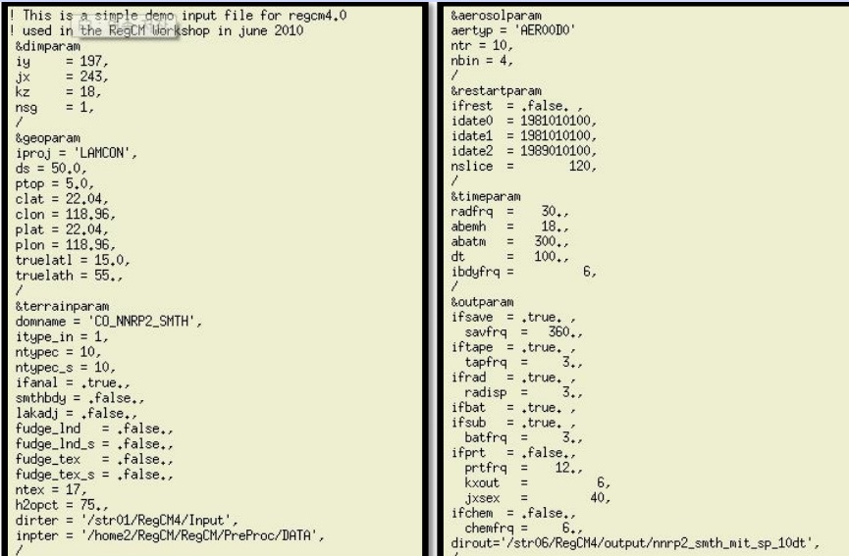
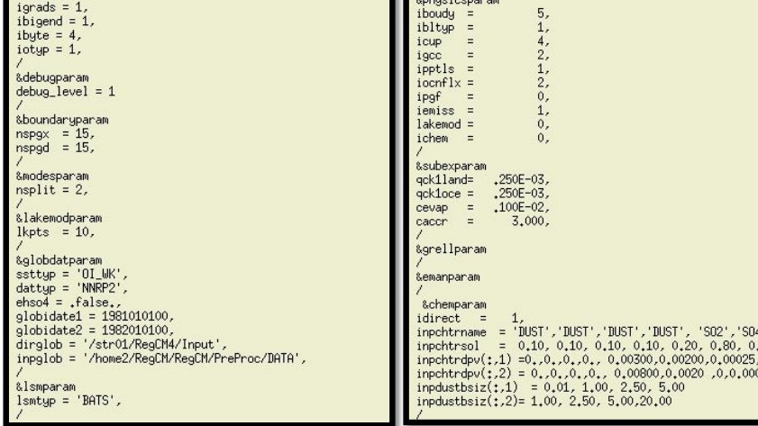
Sample of namelist.in

