Name, Address, email,  E-mail  Telephone Nubmer  Mobile Telephone Number  country of origin  Date of Birth  previous education  previous work experience  First choice of school/motivation  Second choice of school/motivation  computer skills  language skills  one image of my work  Interests |  | IMIAD Student Profile  Alex de Souza  PK.20, Santra,  Saraçoğlu Stadyumu,  34666 Fenerbahçe - İstanbul  alexdesouza@fenerbahce.org  +90 216 666ALEX  +90 533 666ALEX  Brezil, Curitiba, Santa Brigida Birth Hospital  14 Eylül 1977”de saat 2:20  Bachelor of Art  Salon Futbol  Cruzeiro Esporte Clube  Brezilya A Milli Takımı  Istanbul Technical University  3-5 satır  Edinburgh College of art  2-3 satır  Photo Shop  AutoCAD  English - intermediate  Portugues – mother tongue  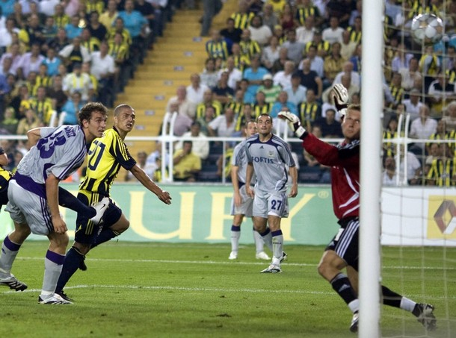  3-5 satır açıklama…  Interior Design – Furniture Design |  | Istanbul  Technical University  Interior Architecture IMIAD  