Chapter 5- Equilibrium of a rigid body

5.1 Conditions for rigid-body equilibrium

Previously we found that a system of forces can be reduced to a force-couple system.

When the force and couple are equal to zero, the body is said to be in equilibrium.

The necessary and sufficient conditions for the equilibrium of rigid body are:

$ΣF=0$ $ΣM=0$

In component form:

$\begin{aligned}{ΣF}_{X}=0 \\ {ΣF}_{Y}=0 \\ {ΣF}_{Z}=0\end{aligned}$ $\begin{aligned}{ΣM}_{X}=0 \\ {ΣM}_{Y}=0 \\ {ΣM}_{Z}=0\end{aligned}$

Equilibrium in two dimensions

5.2 Free-body diagrams

Drawing a FBD, steps
1). Decide which body to analyze.
External 2). Separate this body from everything else and sketch the contour,
forces 3). Draw all applied forces (weight).
4). Draw all reactions.
5). Include any necessary dimensions and coordinate axis.

If you don't know a direction assume a direction and let the sign of the answer tell you if the direction is correct or not.

Rules:
- The magnitude and direction of known forces should be clearly indicated (usually applied forces)
- Indicate the direction of the force exerted on the body, not the force exerted by the body.

Unknown forces are usually the reactions (constraining forces).

Reactions are supports and connections in 2-D, pg. 184-185.

The best 2 ways I have found to determine reactions are:
- Remove the support and see what happens

FBD y x N mg

2. Look at a support and "pull" on it.

$0$ y
$0$ $R_{x}$ x
$R_{y}$

If I pull on the rod, it can't move in x, y direction, but I can make it rotate about 0.

  - Equations of equilibrium

y
$\begin{aligned}{ΣF}_{X}=0 \\ {ΣF}_{Y}=0 \\ {ΣF}_{Z}=0\end{aligned}$ $\begin{aligned}{ΣM}_{X}=0 \\ {ΣM}_{Y}=0 \\ {ΣM}_{Z}=0\end{aligned}$
x 3 equations, 3 unknowns

Let's look at a truss
D Q S

C D

A 0 B

P Q S

FBD

W $A_{X}$

$A_{Y}$ $B_{Y}$

$\begin{aligned}{ΣM}_{A}=0\text{=>}B_{Y} \\ {ΣF}_{X}=0\text{=>}A_{X} \\ {ΣF}_{Y}=0\text{=>}A_{Y}\end{aligned}$
Additional equations could be written.
${ΣM}_{B}=0$ Does not provide any new info.
This is not an independent equation.

You can use ${ΣM}_{B}=0$to replace one of the above 3.

$\begin{aligned}{ΣF}_{X}=0 \\ {ΣM}_{A}=0 \\ {ΣM}_{B}=0\end{aligned}$ or $\begin{aligned}{ΣM}_{A}=0 \\ {ΣM}_{B}=0 \\ {ΣM}_{C}=0\end{aligned}$

Homework:
Read:
Problems 5-12, 19, 23, 27, 30, 38
1). Given
Find: Reactions

$\begin{aligned}{ΣF}_{x}=0 \\ 2+2+R_{\text{Ax}}=0 \\ R_{\text{Ax}}=−4 \text{kN}\end{aligned}$$\begin{aligned}{ΣF}_{y}=0 \\ −3+R_{\text{Ay}}+R_{B}=0\end{aligned}$FBD
$\begin{aligned}{ΣM}_{A}=0 \\ −2(3)−2(1\text{.}5)+R_{B}(2)=0 \\ R_{B}=4\text{.}5 \text{kN}\end{aligned}$ Substituting into R_{B} y-equation: R_{Ay} = -1.5 kN

2). Given
Find: Reactions at A

$\begin{aligned}{ΣF}_{x}=0 \\ R_{\text{Ax}}=0\end{aligned}$$\begin{aligned}{ΣF}_{y}=0 \\ R_{\text{Ay}}−\text{2000}=0 \\ R_{\text{Ay}}=\text{2000} \text{lbs}\end{aligned}$FBD
$\begin{aligned}{ΣM}_{A}=0 \\ M_{A}+\text{3000}−\text{2000}(5)=0 \\ M_{A}=7,\text{000} \text{ft} \text{lbs}\end{aligned}$

3). Given: The bar AB weighs 250 pounds and all surfaces are smooth.
Find: Cable tension and forces at A and C.

$\begin{aligned}{ΣF}_{x}=0 \\ F−R_{C}\text{cos}\text{40}=0 \\ F−0\text{.}\text{766}R_{C}=0\end{aligned}$$\begin{aligned}{ΣF}_{y}=0 \\ R_{A}−W+R_{C}\text{sin}\text{40}=0 \\ R_{A}+R_{C}\text{sin}\text{40}=\text{250} \\ R_{A}+0\text{.}\text{643}R_{C}=\text{250}\end{aligned}$FBD

$\begin{aligned}{ΣM}_{A}=0 \\ −F(2\text{sin}\text{50})−W(6\text{cos}\text{50})+R_{C}(8)=0 \\ −1\text{.}\text{532}F+8R_{C}=\text{964}\text{.}2\end{aligned}$
Solving the above 3 equations simultaneously:
R_{A} = 159.2 lbs
F = 108.2 lbs
R_{C} = 141.2 lbs
4). Given: The loading car weight is 5500 lbs. and its CG is at point G.

Find: tension in cable and reactions at wheels.

FBD
To find $R_{2}$, sum moments about A to eliminate T and R.

$$\begin{aligned}{ΣM}_{A}=0 \\ R_{2}(\text{50})−W_{x}(6)−W_{x}(\text{25})=0 \\ \text{50}R_{2}−\text{5500}\text{cos}{\text{25}}^{∘}(6)−\text{5500}\text{sin}{\text{25}}^{∘}(\text{25})=0 \\ R_{2}=\text{1760} \text{lbs}\end{aligned}$$

To find $R_{1}$, sum moments about B to eliminate T and $R_{2}$

$$\begin{aligned}{ΣM}_{B}=0 \\ −R_{1}(\text{50})−\text{5500}\text{cos}{\text{25}}^{∘}(6)+\text{5500}\text{sin}{\text{25}}^{∘}(\text{25})=0 \\ R_{1}=\text{564} \text{lbs}\end{aligned}$$

To find T:

$$\begin{aligned}{ΣF}_{x}=0 \\ −T+W_{X}=0 \\ T=\text{5500}\text{cos}{\text{25}}^{∘} \\ T=\text{4985} \text{lbs}\end{aligned}$$

Check:

$$\begin{aligned}{ΣF}_{x}=0 \\ \text{564}+\text{1760}−\text{5500}\text{sin}{\text{25}}^{∘}=0 \\ −0\text{.}4≈0\end{aligned}$$

5). Given: The tension in DF is 150 kN
Find: Determine the reactions at E (Pt. E is fixed).

$θ$$\begin{aligned}{ΣF}_{x}=0 \\ −E_{x}+\text{150}\text{sin}θ=0 \\ E_{x}=\text{150}\left(\frac{4\text{.}5}{7\text{.}5}\right) \\ E_{x}=\text{90} \text{kN}\end{aligned}$$\text{DF}=\sqrt{4\text{.}5^{2}+6^{2}}$FBD
$\begin{aligned}{ΣM}_{E}=0 \\ M_{E}+\text{20}(1\text{.}8)(4)+\text{20}(1\text{.}8)(3)+\text{20}(1\text{.}8)(2)+\text{20}(1\text{.}8)−\text{150}\text{sin}θ(6)=0 \\ M_{E}=\text{150}\left(\frac{4\text{.}5}{7\text{.}5}\right)(6)−\text{360} \\ M_{E}=\text{180} \text{kN} m\end{aligned}$$\begin{aligned}{ΣF}_{y}=0 \\ −\text{80}+E_{y}−\text{150}\text{cos}θ=0 \\ E_{y}=\text{80}+\text{150}\left(\frac{6}{7\text{.}5}\right) \\ E_{y}=\text{200} \text{kN}\end{aligned}$

6). Given: the 10 ton moving crane shown below has a mass center at C. It carries a maximum load of 18 tons.

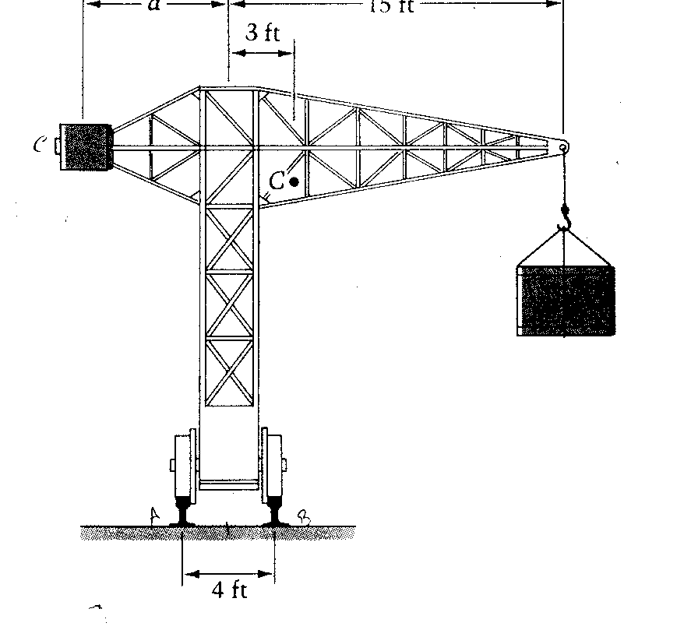

Find: a). The smallest weight of counterweight C, and also the largest distance D, so that:
- the crane doesn't tip cw when the maximum load is lifted
- the crane doesn't tip ccw when there is no load
b). The range of weights C for which (i) and (ii) can be satisfied if d = 2.5 feet.

$\begin{aligned}{ΣM}_{B}=0 \\ W_{C}(d+2)−\text{10}(1)−\text{18}(\text{13})=0 \\ W_{C}(d+2)=\text{244} \\ W_{C}d+2W_{C}=\text{244}\end{aligned}$$\begin{aligned}{ΣM}_{A}=0 \\ W_{C}(d−2)−\text{10}(5)−0(\text{17})=0 \\ W_{C}(d−2)=\text{50} \\ W_{C}d−2W_{C}=\text{50}\end{aligned}$a).

Simultaneously solving the above two equations yields:
W_{c} = 48.5 tons
d = 3.03 feet

$\begin{aligned}{ΣM}_{B}=0 \\ W_{C}(2\text{.}5+2)=\text{244} \\ W_{C}=\text{54}\text{.}2 \text{tons}\end{aligned}$$\begin{aligned}{ΣM}_{A}=0 \\ W_{C}(2\text{.}5−2)=\text{50} \\ W_{C}=\text{100} \text{tons}\end{aligned}$b).

Thus, the range of weights is:
$\text{54}\text{.}2≤W_{C}≥\text{100} \text{tons}$
7) Given: the spring is unstretched when θ = 0, and the spring constant k = 250 lb/in.

Find: Determine the position of equilibrium

FBD
Force of a spring: F = ks s = deflection of spring

Deflection of spring: s = rθ Arclength
F = krθ

$\begin{aligned}{ΣM}_{O}=0 \\ W(8\text{sin}θ)−\text{rF}=0 \\ \text{400}(8\text{sin}θ)−r(\text{kr}θ)=0 \\ \text{3200}\text{sin}θ−(3)(\text{250})(3)θ=0 \\ \text{3200}\text{sin}θ−\text{2250}θ=0\end{aligned}$

How do we solve this
-Graphing y = 3200 sinθ - 2250θ
-Iteratively

