4.4 Principle of Moments

Also known as Varigon's Theorem

Let's say we have several concurrent forces. We can determine its resultant
$R=F_{1}+F_{2}\text{.}\text{.}\text{.}$

The moment of $R$about 0, where $r$is the position vector from 0 to A point on the line of action of $R$.

$\begin{aligned}M_{O}=r×R \\ ]M_{O}=r×(F_{1}+F_{2}+\text{.}\text{.}\text{.}) \\ M_{O}=r×F_{1}+r×F_{2}+\text{.}\text{.}\text{.}\end{aligned}$

The moment about a given 0 of the resultant of several concurrent forces is equal to the sum of the moments of the various forces about the same point 0.

4.5 Moment of a force about a specified axis

$λ$ y
$F$
$M_{O}$ C
$u$
$r$ A x 0 z

Def: The moment M_{λ} of $F$about $λ$is the projection OC of the moment $M_{O}$ on the axis $λ$.

$M_{λ}=u⋅M_{O}=u⋅(r×F)$ A triple scalar product

May be written:

$M_{λ}=u⋅(r×F)=\left|\begin{matrix}u_{x} & u_{y} & u_{z} \\ r_{x} & r_{y} & r_{z} \\ F_{x} & F_{y} & F_{z}\end{matrix}\right|$

4.6 Moment of a couple

Def: Couple - 2 forces $F$ and $−F$ having the same magnitude, parallel lines of action, and opposite direction.
d d
$F$$−F$ ${ΣF}_{y}=0$ but will rotate!
Suppose we have
$M=r_{A}×F+r_{B}×(−F)$
Summing moments about O.
$M=(r_{A}−r_{B})×F$
$r_{B}$ B
$r$$F$ But: $r_{B}+r=r_{A} ⇒ r=r_{A}−r_{B}$

- $−F$ Thus: $M=r×F$
$r_{A}$

A

Note that the right hand side has NO reference to 0, thus $M$is the same for ANY moments center. $M$ is a free vector.

Think of it this way: $F$ creates a moment about some point, $−F$, creates another moment about the same point, usually in the opposite direction. The difference between these 2 moments is
always the same.

As long as the magnitude and direction of $M$ does not change, you have equivalent couples.

In the scalar world:

$M=\text{Fd}$ d

$F$

Homework: Read 4.7 – 4.9
Problems: 4-7, 25, 51, 70, 76, 85, 87
1). Given: A piece of plywood in which several holes are being drilled has been secured to a workbench by means of 2 nails. The drill exerts a 12 Nm torque on the piece of plywood.

A C B 450mm 240mm

Find: The resulting forces applied to the nails if they are located at:

a). A and B
b). B and C
c). A and C

a)
$\begin{aligned}M=\text{Fd} \\ \text{12}=F(0\text{.}\text{45}) \\ F=\text{26}\text{.}7N\end{aligned}$ 12Nm F F 450mm

b).

$\begin{aligned}M=\text{Fd} \\ \text{12}=F(0\text{.}\text{24}) \\ F=\text{50}N\end{aligned}$ 240mm

12Nm

$\begin{aligned}M=\text{Fd} \\ \text{12}=F(0\text{.}\text{51}) \\ F=\text{23}\text{.}5N\end{aligned}$$d=\sqrt{0\text{.}{\text{45}}^{2}+0\text{.}{\text{24}}^{2}}=0\text{.}\text{51}$c).

2). Given: The rod shown below is supported by two brackets at A and B. Given that the magnitude of $F$is 700 N.
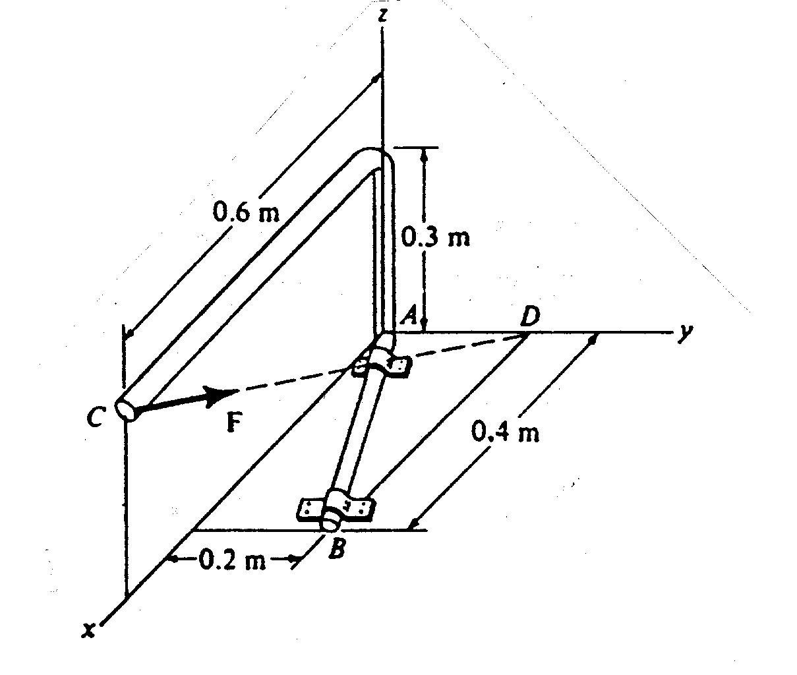

A (0,0,0,)
B (0.4,0.2,0)
C (0,6,0,0.3)
D (0,0.2,0)

Find: The moment about axis AB $M_{\text{AB}}$due to $F$.

$$M_{\text{AB}}=u_{\text{AB}}\text{.}(r_{\text{AC}}×\vec{F}) r_{\text{AC}}=0\text{.}6i+0j+0\text{.}3k$$

$$F=Fu_{\text{CD}}=\text{700}\left(\frac{(0−0\text{.}6)\hat{i}+(0\text{.}2−0)\hat{j}+(0−0\text{.}3)\hat{k}}{\sqrt{0\text{.}6^{2}+0\text{.}2^{2}+0\text{.}3^{2}}}\right)$$

$$F=−\text{600 \{}i+\text{200 \{}\hat{j}−\text{600 \{}\hat{k}$$
$$u_{\text{AB}}=\frac{0\text{.}4\hat{i}+0\text{.}2\hat{j}+0\hat{k}}{\sqrt{0\text{.}4^{2}+0\text{.}2^{2}}}=0\text{.}\text{894 \{}\hat{i}+0\text{.}\text{447 \{}\hat{j}$$

$$M_{\text{AB}}=\left|\begin{matrix}0\text{.}\text{894} & 0\text{.}\text{447} & 0 \\ 0\text{.}6 & 0 & 0\text{.}3 \\ −\text{600} & \text{200} & −\text{300}\end{matrix}\right|=0\text{.}\text{894}[(0)(−\text{300})−(\text{200})(0\text{.}3)]−0\text{.}\text{447}[(0\text{.}6)(−\text{300})−(−\text{600})(0\text{.}3)]+0$$

$M_{\text{AB}}=−\text{53}\text{.}\text{64} \text{Nm}$

3). Given: $F=\hat{i}+3\hat{j}$ lbs

y B
$F$
0 x
$−F$ A (4,-1)
B (3,2)
A 0' (2,-2)
0'

Find: $M_{O}$ and $M_{O^{'}}$due to the couple

$M_{O}=r_{\text{OA}}×F+r_{\text{OB}}×(−F)$) $r_{\text{OA}}=4\hat{i}−\hat{j}$ $r_{\text{OB}}=3\hat{i}+2\hat{j}$

$r_{\text{OA}}×F=\left|\begin{matrix}\hat{i} & \hat{j} & \hat{k} \\ 4 & −1 & 0 \\ 1 & 3 & 0\end{matrix}\right|=0\hat{i}+0\hat{j}+(4(3)−(−1)(1))\hat{k}=\text{13 \{}\hat{k}$ ft lbs

$r_{\text{OB}}×(−F)=\left|\begin{matrix}\hat{i} & \hat{j} & \hat{k} \\ 3 & 2 & 0 \\ −1 & −3 & 0\end{matrix}\right|=0\hat{i}+0\hat{j}+(3(−3)−(−1)(2))\hat{k}=−7\hat{k}$ ft lbs

$M_{O}=\text{13 \{}\hat{k}−7\hat{k} ⇒ M_{O}=6\hat{k}$ ft lbs

$M_{O}=r_{\text{BA}}×F$ $r_{\text{BA}}=\hat{i}−3\hat{j}$

$r_{\text{BA}}×F=\left|\begin{matrix}\hat{i} & \hat{j} & \hat{k} \\ 1 & −3 & 0 \\ 1 & 3 & 0\end{matrix}\right|=0\hat{i}+0\hat{j}+(1(3)−(1)(−3))\hat{k}=6\hat{k}$ ft lbs

$M_{O'}=r_{O'A}×F+r_{O'B}×(−F)$) $r_{O'A}=2\hat{i}+\hat{j}$ $r_{O'B}=\hat{i}+4\hat{j}$

$r_{O'A}×F=\left|\begin{matrix}\hat{i} & \hat{j} & \hat{k} \\ 2 & 1 & 0 \\ 1 & 3 & 0\end{matrix}\right|=0\hat{i}+0\hat{j}+(2(3)−(1)(1))\hat{k}=5\hat{k}$ ft lbs

$r_{O'B}×(−F)=\left|\begin{matrix}\hat{i} & \hat{j} & \hat{k} \\ 1 & 4 & 0 \\ −1 & −3 & 0\end{matrix}\right|=0\hat{i}+0\hat{j}+(1(−3)−(−1)(4))\hat{k}=1\hat{k}$ ft lbs

$M_{O'}=5\hat{k}+1\hat{k} ⇒ M_{O'}=6\hat{k}$ ft lbs

