3.4 Three-Dimensional Force Systems

Again, just like in 2-dimension, Newton's first law must be satisfied.

$ΣF=0$

The only difference is now the forces have 3 components.

${ΣF}_{x}=0$ ${ΣF}_{y}=0$ ${ΣF}_{z}=0$

Use vectors in 3_D!! How many unknowns can we solve for? 3

FBD !!

1). Given: The weight of the crate is 2025 lbs.

Find: the tension in the 3 cables
$T_{\text{AC}}$
$\begin{aligned}ΣF=0 \\ T_{\text{AB}}+T_{\text{AC}}+T_{\text{AD}}+W=0\end{aligned}$FBD
$T_{\text{AB}}$$T_{\text{AD}}$

$W$

$W=\text{2025 \{}\hat{j}$

$T_{\text{AB}}=T_{\text{AB}}u_{\text{AB}}$
A(0,-45,0)
$T_{\text{AB}}=T_{\text{AB}}\left(\frac{(\text{28}−0)\hat{i}+(0−(−\text{45}))\hat{j}+(0−0)\hat{k}}{\sqrt{{\text{28}}^{2}+{\text{45}}^{2}+0^{2}}}\right)$B(28,0,0)
C(0,0,-24)
D(-26,0,18)
$T_{\text{AB}}=0\text{.}\text{528}T_{\text{AB}}\hat{i}+0\text{.}\text{849}T_{\text{AB}}\hat{j}$

$T_{\text{AC}}=T_{\text{AC}}u_{\text{AC}}$
$T_{\text{AC}}=T_{\text{AC}}\left(\frac{(0−0)\hat{i}+(0−(−\text{45}))\hat{j}+(−\text{24}−0)\hat{k}}{\sqrt{0^{2}+{\text{45}}^{2}+{\text{24}}^{2}}}\right)$

$T_{\text{AC}}=0T_{\text{AC}}\hat{i}+0\text{.}\text{882}T_{\text{AC}}\hat{j}−0\text{.}\text{471}T_{\text{AC}}\hat{k}$

$T_{\text{AD}}=T_{\text{AD}}u_{\text{AD}}$
$T_{\text{AD}}=T_{\text{AD}}\left(\frac{(−\text{26}−0)\hat{i}+(0−(−\text{45}))\hat{j}+(\text{18}−0)\hat{k}}{\sqrt{{\text{26}}^{2}+{\text{45}}^{2}+{\text{18}}^{2}}}\right)$

$T_{\text{AD}}=−0\text{.}\text{473}T_{\text{AD}}\hat{i}+0\text{.}\text{818}T_{\text{AD}}\hat{j}+0\text{.}\text{327}T_{\text{AD}}\hat{k}$

Substituting and collecting like terms:

$$(0\text{.}\text{528}T_{\text{AB}}+0T_{\text{AC}}−0\text{.}\text{473}T_{\text{AD}})\hat{i}+(0\text{.}\text{849}T_{\text{AB}}+0\text{.}\text{882}T_{\text{AC}}+0\text{.}\text{818}T_{\text{AC}}−\text{2025})\hat{j}$$
$+(0T_{\text{AB}}−0\text{.}\text{471}T_{\text{AC}}+0\text{.}\text{327}T_{\text{AD}})\hat{k}=0$

$\begin{aligned}0\text{.}\text{528}T_{\text{AB}}+0T_{\text{AC}}−0\text{.}\text{473}T_{\text{AD}}=0 \\ 0\text{.}\text{849}T_{\text{AB}}+0\text{.}\text{882}T_{\text{AC}}+0\text{.}\text{818}T_{\text{AD}}=\text{2025} \\ 0T_{\text{AB}}−0\text{.}\text{471}T_{\text{AC}}+0\text{.}\text{327}T_{\text{AD}}=0\end{aligned}$ Solving:
$\begin{aligned}T_{\text{AB}}=\text{828} \text{lbs} \\ T_{\text{AC}}=\text{642} \text{lbs} \\ T_{\text{AD}}=\text{924} \text{lbs}\end{aligned}$

2). Given: One of the three landing pads for
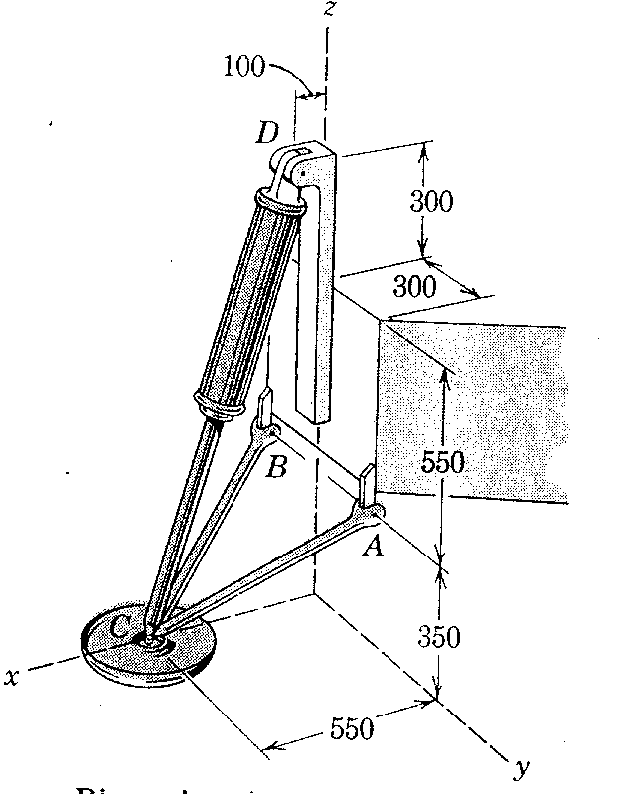
the Mars Viking lander is shown in the figure
with its approximate dimensions. The mass of
the lander is 600 kg. Compute the force in each
leg when the lander is resting on a horizontal
surface on Mars

$T_{\text{BC}}$$T_{\text{DC}}$FBD
$T_{\text{AC}}$

C

$N$
$\begin{aligned}m=\text{600}\text{kg} \\ a_{\text{MARS}}=3\text{.}\text{73} m/{s^{2}} \\ W=\text{600}(3\text{.}\text{73}) \\ W=\text{2238} N \frac{W}{3}=\text{746}N\end{aligned}$
A(0,300,350) C(550,0,0)
B(0,-300,350) D(100,0,1200)

$\begin{aligned}ΣF=0 \\ T_{\text{AC}}+T_{\text{BC}}+T_{\text{DC}}+N=0\end{aligned}$

$N=\text{746 \{}\hat{k}$$T_{\text{AC}}=T_{\text{AC}}\left(\text{550 \{}\hat{i}−\text{300 \{}\hat{j}−\text{350 \{}\hat{k} | | \frac{}{\sqrt{{\text{550}}^{2}+{\text{300}}^{2}+{\text{350}}^{2}}} | \right)$$\begin{aligned}T_{\text{BC}}=T_{\text{BC}}\left(\text{550 \{}\hat{i}+\text{300 \{}\hat{j}−\text{350 \{}\hat{k} | | \frac{}{\sqrt{{\text{550}}^{2}+{\text{300}}^{2}+{\text{350}}^{2}}} | \right) \\ T_{\text{BC}}=0\text{.}\text{7664}T_{\text{BC}}\hat{i}+0\text{.}\text{4181}T_{\text{BC}}\hat{j}−0\text{.}\text{4877}T_{\text{BC}}\hat{k}\end{aligned}$

$T_{\text{AC}}=0\text{.}\text{7664}T_{\text{AC}}\hat{i}−0\text{.}\text{418}T_{\text{AC}}\hat{j}−0\text{.}\text{4877}T_{\text{AC}}\hat{k}$

$\begin{aligned}T_{\text{DC}}=T_{\text{DC}}\left(\text{450 \{}\hat{i}+0\hat{j}−\text{1200 \{}\hat{k} | | \sqrt{{\text{450}}^{2}+0^{2}+{\text{1200}}^{2}} | \right) \\ T_{\text{DC}}=0\text{.}\text{3511}T_{\text{DC}}\hat{i}+0T_{\text{DC}}\hat{j}−0\text{.}\text{9363}T_{\text{DC}}\hat{k}\end{aligned}$

Substituting and collecting like terms: Solving:
$\begin{aligned}T_{\text{AC}}=\text{239}\text{.}7N \\ T_{\text{BC}}=\text{239}\text{.}7N \\ T_{\text{DC}}=\text{1047}N\end{aligned}$$\begin{aligned}0\text{.}{\text{7664}}_{\text{AC}}+\text{07664}T_{\text{BC}}+0\text{.}\text{3511}T_{\text{DC}}=0 \\ −0\text{.}\text{4181}T_{\text{AC}}+0\text{.}\text{4181}T_{\text{BC}}+0T_{\text{DC}}=0 \\ −\text{04877}T_{\text{AC}}−0\text{.}\text{4877}T_{\text{BC}}−\text{09363}T_{\text{DC}}=\text{746}\end{aligned}$

3). Given: In trying to move across an icy surface, a 175 pound man at A uses 2 ropes AB and AC. Remember, the force exerted on the man by the icy surface is perpendicular to that surface.
y

B C 4 ft

8 ft O
x
z
16 ft 32 ft 12ft

A

30 ft

Find: The tension in each rope.

FBD
$\begin{aligned}ΣF=0 \\ T_{\text{AC}}+T_{\text{AB}}+N+W=0\end{aligned}$ $T_{\text{AC}}$

$$T_{\text{AB}}$$
A(30,-16,12)
A B(0,8,44)
$N$ C(0,4,0)
$W=−\text{175 \{}\hat{j}$$W$

y
$\begin{aligned}N=N\text{sin}θ \hat{i}+N\text{cos}θ \hat{j} \\ N=\frac{\text{16}}{\text{34}}N\hat{i}+\frac{\text{30}}{\text{34}}N\hat{j} \\ N=0\text{.}\text{471}N\hat{i}+0\text{.}\text{8824}N\hat{j}\end{aligned}$
$N$ 16 34 θ x 30 θ

$\begin{aligned}T_{\text{AB}}=T_{\text{AB}}\left(−\text{30 \{}\hat{i}+\text{24 \{}\hat{j}+\text{32 \{}\hat{k} | | \frac{}{\sqrt{{\text{30}}^{2}+{\text{24}}^{2}+{\text{32}}^{2}}} | \right) \\ T_{\text{AB}}=−0\text{.}6T_{\text{AB}}\hat{i}+0\text{.}\text{48}T_{\text{AB}}\hat{j}+0\text{.}\text{64}T_{\text{AB}}\hat{k}\end{aligned}$$\begin{aligned}T_{\text{AC}}=T_{\text{AC}}\left(−\text{30 \{}\hat{i}+\text{20 \{}\hat{j}−\text{12 \{}\hat{k} | | \frac{}{\sqrt{{\text{30}}^{2}+{\text{20}}^{2}+{\text{12}}^{2}}} | \right) \\ T_{\text{AC}}=−0\text{.}\text{7895}T_{\text{AC}}\hat{i}+0\text{.}\text{5623}T_{\text{AC}}\hat{j}−0\text{.}\text{3158}T_{\text{AC}}\hat{k}\end{aligned}$

Substituting and collecting like terms:
$$\begin{aligned}(−0\text{.}\text{7895}T_{\text{AC}}−0\text{.}6T_{\text{AB}}+0\text{.}\text{471}N)\hat{i}+(0\text{.}\text{5623}T_{\text{AC}}+0\text{.}\text{48}T_{\text{AB}}+0\text{.}\text{8824}N−\text{175})\hat{j} \\ +(−0\text{.}\text{3158}T_{\text{AC}}+0\text{.}\text{64}T_{\text{AB}}+0N)\hat{k}=0\end{aligned}$$

$$\begin{aligned}−0\text{.}\text{7895}T_{\text{AC}}−0\text{.}6T_{\text{AB}}+0\text{.}\text{471}N=0 \\ 0\text{.}\text{5623}T_{\text{AC}}+0\text{.}\text{48}T_{\text{AB}}+0\text{.}\text{8824}N=\text{175} \\ −0\text{.}\text{3158}T_{\text{AC}}+0\text{.}\text{64}T_{\text{AB}}+0N=0\end{aligned}$$

Solving:

$$\begin{aligned}T_{\text{AC}}=\text{61}\text{.}8 \text{lbs} \\ T_{\text{AB}}=\text{30}\text{.}5 \text{lbs} \\ N=\text{142} \text{lbs}\end{aligned}$$

