Chapter 3- Equilibrium

3.1 Condition for the Equilibrium of a Particle

-Newton First Law Must be Satisfied
Resultant Force Acting on a Particle Must be Zero
$ΣF=0$

Necessary and Sufficient Condition

In component form: ${ΣF}_{x}=0$ ${ΣF}_{y}=0$

3.2 The Free-Body Diagram (FBD)
We must account for all the forces acting on a particle. The best way to do this is to
draw an FBD.

An FBD is a sketch of the particle isolated (or free) from its surroundings shown with all the forces that act on the particle.

IMPORTANT! F=ks (F=kΔx)
(F=kx)
s

Springs

Cables and Pulleys Cables - Negligible weight
- Cannot be stretched
- Support only tension
(can't push a rope)

Pulleys - Frictionless

Steps for Drawing a FBD
- Decide which body to analyze
- Separate this body from everything else and sketch the contour
- Draw all applied forces
- Include any necessary dimensions and coordinate axis

Steps 3 and 4- These are external forces

Applied forces - think of these as forces that try to get the particle to move.
Reaction forces - forces that try to prevent motion.
Note: When drawing the forces, if you don't know the direction, assume a direction and let the sign of the answer tell you if the direction is correct or not.

Rules of FBD
1). Magnitude and direction of all forces should be clearly indicated.
2). Indicate the direction of the force on the body.

  - Coplanar Force System

$$\begin{aligned}ΣF=0 \\ ΣF=ΣF_{x}\hat{i}+{ΣF}_{y}\hat{j}=0\hat{i}+0\hat{j} \\ \text{=>} {ΣF}_{x}=0 {ΣF}_{y}=0\end{aligned}$$

Thus, what is the most number of unknowns we can solve? 2

1). Given: Mass of the crate is 50 kg

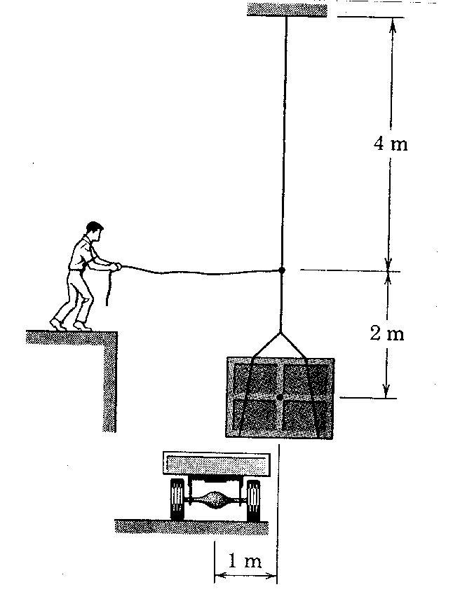

Find: The horizontal force, P, needed to position the crate directly over the wagon.

FBD(knot) 1m

θ
T W=50 (9.81)
4m W= 490.5 N
P

490.5N

$\begin{aligned}{ΣF}_{x}=0 \\ T\text{cos}θ−P=0\end{aligned}$ $\begin{aligned}{ΣF}_{Y}=0 \\ T\text{sin}θ−\text{490}\text{.}5=0\end{aligned}$ $\begin{aligned}\text{cos}θ=1/4 \\ θ=\text{75}\text{.}{\text{52}}^{∘}\end{aligned}$

$\begin{aligned}T\text{sin}\text{75}\text{.}{\text{52}}^{∘}=\text{490}\text{.}5 \\ T=\text{506}\text{.}6N\end{aligned}$

$$\begin{aligned}\text{506}\text{.}6\text{cos}\text{75}\text{.}{\text{52}}^{∘}=P \\ P=\text{126}\text{.}7 N\end{aligned}$$
2). Given:

15"

h

B 65
lbs
A
60lbs

The 60pound collar slides on a frictionless rod.

Find: the value of h for which the system is in equilibrium.

FBD 65lbs
θ

$F_{x}$

60lbs

$\begin{aligned}{ΣF}_{y}=0 \\ \text{65}\text{sin}θ−\text{60}=0 \\ θ=\text{67}\text{.}{\text{38}}^{∘}\end{aligned}$ $\begin{aligned}\text{tan}θ=h/{\text{15}} \\ h=\text{15}\text{tan}\text{67}\text{.}{\text{38}}^{∘} \\ h=\text{36} \text{in}\end{aligned}$
3). Given: The body has a mass of 76 slugs

A B

${\text{40}}^{∘}$ ${\text{30}}^{∘}$

C
D ${\text{60}}^{∘}$

Find: The tension in cables A, B, C, and D.

We have 2 E.O.E. so we can only solve for 2 unknowns. The top knot has 3 unknowns (A,B,C) and the bottom knot has 2 unknowns (C,D)

FBD (Bottom) C W= 76 (32.2)
W= 2447 lbs
${\text{60}}^{∘}$
D

2447 lbs
$\begin{aligned}{ΣF}_{x}=0 \\ C\text{cos}{\text{60}}^{∘}−D=0\end{aligned}$ $\begin{aligned}{ΣF}_{y}=0 \\ C\text{sin}{\text{60}}^{∘}−\text{2447}=0 \\ C=\text{2826} \text{lbs}\end{aligned}$

$\begin{aligned}D=\text{2826}\text{cos}{\text{60}}^{∘} \\ D=\text{1413} \text{lbs}\end{aligned}$

FBD$\begin{aligned}{ΣF}_{x}=0 \\ B\text{cos}{\text{30}}^{∘}−A\text{cos}{\text{40}}^{∘}−\text{2826}\text{cos}{\text{60}}^{∘}=0 \\ −0\text{.}\text{766}A+0\text{.}\text{866}B=\text{1413}\end{aligned}$ (top)
$\begin{aligned}{ΣF}_{y}=0 \\ B\text{sin}{\text{30}}^{∘}+A\text{sin}{\text{40}}^{∘}−\text{2826}\text{sin}{\text{60}}^{∘}=0 \\ 0\text{.}\text{643}A+0\text{.}5B=\text{2447}\end{aligned}$

A=1503 lbs B = 2961 lbs

