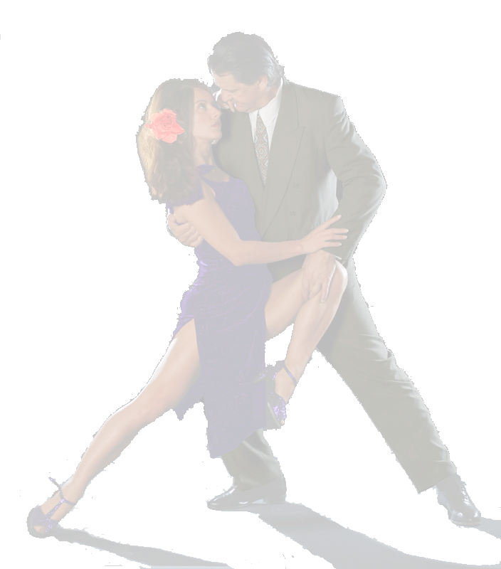
Wednesday, Sep. 6 - Milonga and Shows
Prices:
2 Class 60 YTL (32 €)
4 Class 100 YTL (54 €)
Every following class after 4 classes 20 YTL. (11 €)
Each class is 90 minutes.
Tel: 0532 3376490

Thursday, Sep. 7
19.00 - 20.30 Tango - Beginners
Posture and embrace ( abrazo) / Control of the weights
Different kinds of salidas/ ochos/ combined movements
and cuts of the learnt structures.
Essence of tango, technique and the ´feeling
20.45 - 22.15 Tango - Beginners and Intermediates
Various sequences- playing with separate elements and the whole sequences
application of half times / giro in 3, using parts of giro
simple boleos Caminatas with and without half time
Using three possible ways and advancing with a partner
Contact:
dkenanj@yahoo.com
kkutlu@gmail.com

Friday, Sep. 8
19.00 - 20.30 Milonga - Beginners
HOW FROM SIMPLE STEPS BUILD A VERY FUNNY AND COMPLEX MILONGA
Posture and embrace ( abrazo) / Control of the weight in milonga rythm
Stepping and changing weight simultaneously with a partner
Basic structures / ochitos and accompanying / sobrepasos
Combinations of applied structures and sequences
20.45 - 22.15 Milonga- Beginners and Intermediates
HOW TO PUT MORE SPICE IN YOUR MILONGA. THE TURNING TORSO
Sequences in time and half time / concept of traspie / caminatas
Figures in reduced space / changes of direction / changes of dinamics
Pivotes and parts of enrosques in milonga/ some simple ornaments

Saturday, Sep. 9 (MILONGA + Fashion Show 21:00-02:00)
13.30 - 15:00 Technique for men/Technique for women
These are separate classes and will be simultaneously
15.- 16.30. Tango - Intermediates and Advanced
Various sequences / Application of half times (medio tiempo)
Giros / enrosques / boleos
Caminatas with or without medio tiempo
Use of the 3 possible ways of advancing
16.45 - 18.15 Milonga - Intermediates and Advanced
Sequences in time and half time (tiempos and medio tiempos)
Principle of traspie / Caminatas / Figures in reduced space
Change of direction / Changes of dinamics / Advanced changes of directions.
18.30 - 20.00 Vals - Intermediates and Advanced
Shared axis (Ejes compartidos) / Concept of dinamic pause
Tension and dinamics in vals / Sequences of giros
Sacadas with both legs.
21:00-02:00 MILONGA + Fashion Show

Sunday, Sep. 10
15.- 16.30. Tango - Intermediates and Advanced
Combinations Sacadas - Boleos - Barridas
Sacadas and its opposite: Colgadas
Applied volcadas
Ganchos internos and externos , Application in the tango salon
16.45 - 18.15 Milonga - Intermediates and Advanced
Combinations of Traspie and Medios Tiempos
Corriditas / Trenzados
Adaptation of the linear and circular sequences
Ornaments / Various Caminatas
18.30 - 20.00 Vals - Intermediates and Advanced
Sequences of shared axis advancing / Changes of direction in Giro/
Changes of direction while advancing / Colgadas / Volcadas
Changing the roles: Axis and Circumference

