**SCREW PROPELLERS – APPLICATIONS**

**1-**

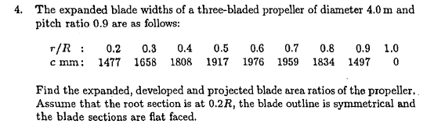

|  |  |  |  |  |  |  |
| --- | --- | --- | --- | --- | --- | --- |
|  |  |  |  |  | Z= | 3 |
| **r/R** | **c(m)** | **SM** | **c(m)*SM** |  | D(m)= | 4 |
| 0.2 | 1.477 | 1 | 1.477 |  | R(m)= | 2 |
| 0.3 | 1.658 | 4 | 6.632 |  | h=0.1R | 0.2 |
| 0.4 | 1.808 | 2 | 3.616 |  |  |  |
| 0.5 | 1.917 | 4 | 7.668 |  |  |  |
| 0.6 | 1.976 | 2 | 3.952 |  |  |  |
| 0.7 | 1.959 | 4 | 7.836 |  |  |  |
| 0.8 | 1.834 | 2 | 3.668 |  |  |  |
| 0.9 | 1.497 | 4 | 5.988 |  |  |  |
| 1 | 0 | 1 | 0 |  |  |  |
|  |  | sum | 40.837 |  |  |  |
|  |  | h= | 0.2 |  |  |  |
|  | area= | h/3*sum= | 2.722467 | m2 |  |  |
|  | disk area= | pi*r^2= | 12.56637 | m2 |  |  |
|  | Ear= | area/disk= | 0.649941 |  |  |  |

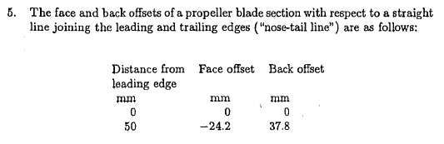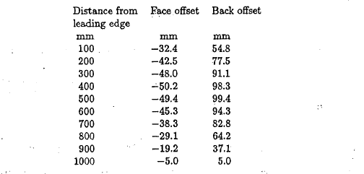

**2-**

|  |  |  |  |  |  |  |
| --- | --- | --- | --- | --- | --- | --- |
|  | x(mm) | face(mm) | back(mm) |  | thickness | camber |
| Le | 0 | 0 | 0 |  | 0 | 0 |
|  | 50 | -24.2 | 37.8 |  | 62 | 6.8 |
|  | 100 | -32.4 | 54.8 |  | 87.2 | 11.2 |
|  | 200 | -42.5 | 77.5 |  | 120 | 17.5 |
|  | 300 | -48 | 91.1 |  | 139.1 | 21.55 |
|  | 400 | -50.2 | 98.3 |  | 148.5 | 24.05 |
|  | 500 | -49.4 | 99.4 |  | 148.8 | 25 |
|  | 600 | -45.3 | 94.3 |  | 139.6 | 24.5 |
|  | 700 | -38.3 | 82.8 |  | 121.1 | 22.25 |
|  | 800 | -29.1 | 64.2 |  | 93.3 | 17.55 |
|  | 900 | -19.2 | 37.1 |  | 56.3 | 8.95 |
| Te | 1000 | -5 | 5 |  | 10 | 0 |

|  |  |
| --- | --- |
| t/c= | 0.1488 |
| f/c= | 0.025 |

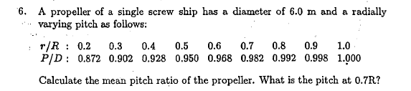

**3-**

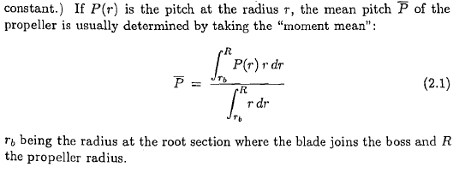

|  |  |  |  |  |
| --- | --- | --- | --- | --- |
| **r/R** | **P/D** | **r/R*P/D** | **SM** | **r/R*P/D*SM** |
| 0.2 | 0.872 | 0.1744 | 1 | 0.1744 |
| 0.3 | 0.902 | 0.2706 | 4 | 1.0824 |
| 0.4 | 0.928 | 0.3712 | 2 | 0.7424 |
| 0.5 | 0.95 | 0.475 | 4 | 1.9 |
| 0.6 | 0.968 | 0.5808 | 2 | 1.1616 |
| 0.7 | 0.982 | 0.6874 | 4 | 2.7496 |
| 0.8 | 0.992 | 0.7936 | 2 | 1.5872 |
| 0.9 | 0.998 | 0.8982 | 4 | 3.5928 |
| 1 | 1 | 1 | 1 | 1 |
|  |  |  | sum= | 13.9904 |
|  |  |  | h=0.1= | 0.1 |
|  |  | Area= | h/3*sum | 0.466347 |
|  |  | Area-2 | (1-0.2^2)/2 | 0.48 |
|  |  |  |  | 0.971556 |
| Pitch @0.7R | | 5.892 |  |  |

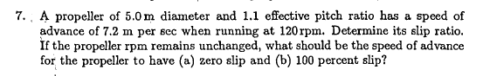

**4-**













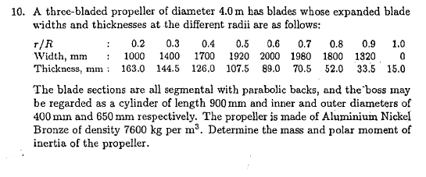

**5-**

|  |  |  |  |  |  |  |
| --- | --- | --- | --- | --- | --- | --- |
| D= | 4 | m |  |  |  |  |
|  |  |  |  |  |  |  |
| **r/R** | **r(cm)** | **w(cm)** | **t(cm)** | **A(cm^2)** | **m(kg)** | **Iox(kg.m2)** |
| 0.2 | 40 | 100 | 16.3 | 1086.7 | 0.0 | 0.0 |
| 0.3 | 60 | 140 | 14.45 | 1348.7 | 185.1 | 46.3 |
| 0.4 | 80 | 170 | 12.6 | 1428.0 | 211.0 | 103.4 |
| 0.5 | 100 | 192 | 10.75 | 1376.0 | 213.1 | 172.6 |
| 0.6 | 120 | 200 | 8.9 | 1186.7 | 194.8 | 235.7 |
| 0.7 | 140 | 198 | 7.05 | 930.6 | 160.9 | 271.9 |
| 0.8 | 160 | 180 | 5.2 | 624.0 | 118.1 | 265.8 |
| 0.9 | 180 | 132 | 3.35 | 294.8 | 69.8 | 201.8 |
| 1 | 200 | 0 | 1.2 | 0.0 | 22.4 | 80.9 |

|  |  |  |  |  |  |  |
| --- | --- | --- | --- | --- | --- | --- |
| rho_m= | 7600 | kg/m3 |  |  |  |  |
| m= | 1175.27 | kg |  |  |  |  |
| Iox= | 1378.42 | kg.m2 |  |  |  |  |
| Z= | 3 |  |  |  |  |  |
| Iox= | **4135.249** | kg.m2 | (propeller inertia in air excluding hub) | | | |
| Iox= | 5375.824 | kg.m2 | (propeller inertia in water excluding hub) | | | |

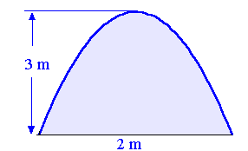

Area Computation

t

w

A=2/3 t w

|  |  |  |  |  |
| --- | --- | --- | --- | --- |
|  | L= | | 0.9 |  |
|  | Ri= | | 0.2 |  |
|  | Ro= | | 0.325 |  |
| m= | rho*pi*Ri^2*L | | 859.5398 | kg |
|  | Ibos= | | **62.58524** | kg.m2 |
| I=Iox+Ibos | 4197.834 |

