PROPELLER IN OPEN WATER – APPLICATIONS
1-
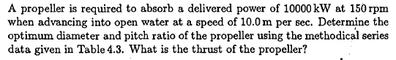
Pd(kW) | 10000
N(rpm) | 150
V_{A}(m/s) | 10
D(m) | ?
P/D | ?
T (kN) | ?

Open water data of Propeller B 4.50
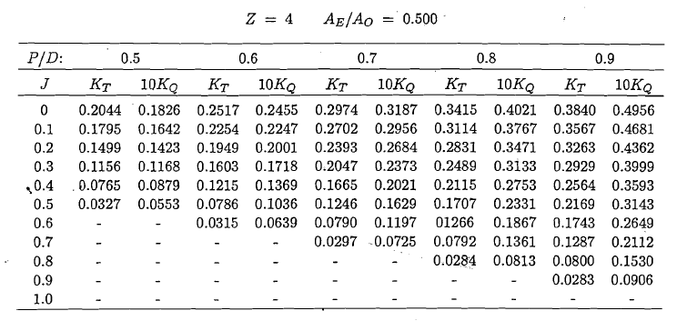
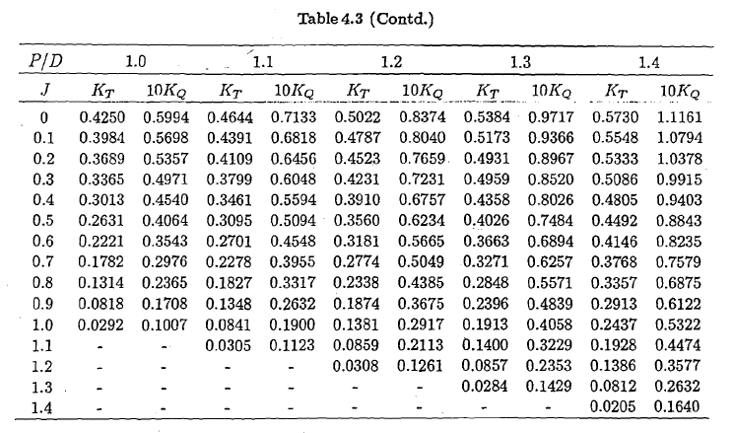

Solution: The problem suits for the Case 3 which is “Optimum propeller for given power and rate” since engine power and rotation rate have been given.
The parameterr given in the problem are to be used in this case is K_{Q}/J⁵ since in this parameter the power and the rotation rate are present and the diameter is eliminated.

Each column of table given above is scanned by calculating Eta0 and value of K_{Q}/J⁵ with Kt and Kq values. Then, an interpolation is performed for each column for data given in the problem as “0.097”. The performance data are obtained as shown righy side of each column data.
P/D | 0.9
J | Kt | 10Kq | η0 | Kq/J^5 | 0.097
0.0 | 0.3840 | 0.4956 | 0.0000 | -
0.1 | 0.3567 | 0.4681 | 0.1213 | 4681.0000
0.2 | 0.3263 | 0.4362 | 0.2381 | 136.3125
0.3 | 0.2929 | 0.3999 | 0.3497 | 16.4568
0.4 | 0.2564 | 0.3593 | 0.4543 | 3.5088
0.5 | 0.2169 | 0.3143 | 0.5492 | 1.0058
0.6 | 0.1743 | 0.2649 | 0.6283 | 0.3407 |  | eta0 | J | Kt | 10Kq
0.7 | 0.1287 | 0.2112 | 0.6789 | 0.1257 | 1 | 0.676851 | 0.736058 | 0.11114 | 0.189601
0.8 | 0.0800 | 0.1513 | 0.6732 | 0.0462 | 0
0.9 | 0.0283 | 0.0906 | 0.4474 | 0.0153

P/D | 1
J | Kt | 10Kq | η0 | Kq/J^5
0.0 | 0.4250 | 0.5994 | 0.0000 | -
0.1 | 0.3984 | 0.5698 | 0.1113 | 5698.0000
0.2 | 0.3689 | 0.5357 | 0.2192 | 167.4063
0.3 | 0.3365 | 0.4971 | 0.3232 | 20.4568
0.4 | 0.3013 | 0.4540 | 0.4225 | 4.4336
0.5 | 0.2631 | 0.4064 | 0.5152 | 1.3005
0.6 | 0.2221 | 0.3543 | 0.5986 | 0.4556 |  | eta0 | J | Kt | 10Kq
0.7 | 0.1782 | 0.2976 | 0.6671 | 0.1771 | 1 | 0.697874 | 0.776333 | 0.142476 | 0.250961
0.8 | 0.1314 | 0.2365 | 0.7074 | 0.0722 | 0
0.9 | 0.0818 | 0.1708 | 0.6860 | 0.0289
1.0 | 0.0292 | 0.1007 | 0.4615 | 0.0101

P/D | 1.1
J | Kt | 10Kq | η0 | Kq/J^5
0.0 | 0.4644 | 0.7133 | 0.0000 | -
0.1 | 0.4391 | 0.6818 | 0.1025 | 6818.0000
0.2 | 0.4109 | 0.6456 | 0.2026 | 201.7500
0.3 | 0.3799 | 0.6048 | 0.2999 | 24.8889
0.4 | 0.3461 | 0.5594 | 0.3939 | 5.4629
0.5 | 0.3095 | 0.5094 | 0.4835 | 1.6301
0.6 | 0.2701 | 0.4548 | 0.5671 | 0.5849
0.7 | 0.2278 | 0.3955 | 0.6417 | 0.2353 |  | eta0 | J | Kt | 10Kq
0.8 | 0.1827 | 0.3317 | 0.7013 | 0.1012 | 1 | 0.70371 | 0.807461 | 0.179126 | 0.326589
0.9 | 0.1348 | 0.2632 | 0.7336 | 0.0446 | 0
1.0 | 0.0841 | 0.1900 | 0.7045 | 0.0190
1.1 | 0.0305 | 0.1123 | 0.4755 | 0.0070

P/D | 1.2
J | Kt | 10Kq | η0 | Kq/J^5
0.0 | 0.5022 | 0.8374 | 0.0000 | -
0.1 | 0.4787 | 0.8040 | 0.0948 | 8040.0000
0.2 | 0.4523 | 0.7659 | 0.1880 | 239.3438
0.3 | 0.4231 | 0.7231 | 0.2794 | 29.7572
0.4 | 0.3910 | 0.6757 | 0.3684 | 6.5986
0.5 | 0.3560 | 0.6234 | 0.4544 | 1.9949
0.6 | 0.3181 | 0.5665 | 0.5362 | 0.7285
0.7 | 0.2774 | 0.5049 | 0.6121 | 0.3004 |  | eta0 | J | Kt | 10Kq
0.8 | 0.2338 | 0.4385 | 0.6789 | 0.1338 | 1 | 0.705386 | 0.851436 | 0.209934 | 0.40198
0.9 | 0.1874 | 0.3675 | 0.7304 | 0.0622 | 0
1.0 | 0.1381 | 0.2917 | 0.7535 | 0.0292
1.1 | 0.0859 | 0.2113 | 0.7117 | 0.0131
1.2 | 0.0308 | 0.1261 | 0.4665 | 0.0051

P/D | 1.3
J | Kt | 10Kq | η0 | Kq/J^5
0.0 | 0.5384 | 0.9717 | 0.0000 | -
0.1 | 0.5173 | 0.9366 | 0.0879 | 9366.0000
0.2 | 0.4931 | 0.8967 | 0.1750 | 280.2188
0.3 | 0.4959 | 0.8520 | 0.2779 | 35.0617
0.4 | 0.4358 | 0.8026 | 0.3457 | 7.8379
0.5 | 0.4026 | 0.7484 | 0.4281 | 2.3949
0.6 | 0.3663 | 0.6894 | 0.5074 | 0.8866
0.7 | 0.3271 | 0.6257 | 0.5824 | 0.3723
0.8 | 0.2848 | 0.5571 | 0.6509 | 0.1700 |  | eta0 | J | Kt | 10Kq
0.9 | 0.2396 | 0.4839 | 0.7092 | 0.0819 | 1 | 0.699271 | 0.882909 | 0.247325 | 0.496411
1.0 | 0.1913 | 0.4058 | 0.7503 | 0.0406 | 0
1.1 | 0.1400 | 0.3229 | 0.7591 | 0.0200
1.2 | 0.0857 | 0.2353 | 0.6956 | 0.0095
1.3 | 0.0284 | 0.1429 | 0.4112 | 0.0038

The column where the maximum efficiency obtained is selected. In this example maximum efficiency is obtained as 0.705 for the column P/D=1.2 but the column P/D=1.1 is preferred because the efficiencies are very close each other. The lower P/D values should be preferred in order to avoid cavitation risk.
The latter is an easy procedure because J, Kt, and Kq values are known;

Alternatively you can use the program “PROPCALC” with the data given below
#..... OPTIMIZASYON SECENEGI INDISINI VE GEREKLI DEGERLERI GIRINIZ .......#
3
10000. 10. 150. 1025. 4 0.5
DHP, VA, RPM, RHO, Z, AE

The output is a little bit different since the performance data are slightly different.
------------------------------------------------------------------------
! Program: PropCalc Versiyon: 10/12/2016 Dr. Ali Can TAKiNACI !
! !
! WAGENINGEN/GAWN SERISI PERVANE HIDRODINAMIK KARAKTERISTILERI !
! HESAP PROGRAMI !
------------------------------------------------------------------------

Pervane Karakteristikleri - Kq/J^5 = 0.097

----|-------|-------|--------|--------|--------|------------|-----------|
i P/D J Kt 10Kq eta0 Bp delta
----|-------|-------|--------|--------|--------|------------|-----------|
1 0.500 0.552 0.0111 0.0496 0.1972 10.3011 183.5804
2 0.510 0.556 0.0136 0.0517 0.2327 10.3011 182.0222
3 0.520 0.561 0.0161 0.0540 0.2658 10.3012 180.4861
………………………………………………………………………………………………………………………………..
45 0.940 0.749 0.1316 0.2290 0.6854 10.3012 135.1716
46 0.950 0.753 0.1346 0.2352 0.6861 10.3012 134.4511
47 0.960 0.757 0.1376 0.2415 0.6866 10.3012 133.7424

48 0.970 0.761 0.1406 0.2479 0.6870 10.3012 133.0455

49 0.980 0.765 0.1436 0.2544 0.6873 10.3012 132.3599
………………………………………………………………………………………………………………………………..
68 1.170 0.835 0.2013 0.3948 0.6778 10.3012 121.2228
69 1.180 0.839 0.2043 0.4030 0.6769 10.3012 120.7238
70 1.190 0.842 0.2074 0.4113 0.6760 10.3012 120.2325

HESAPLARDA WAGENINGEN B SERISI KULLANILMISTIR

SECILEN PERVANE = 48. PERVANEDIR

P/D=0.970
J= 0.761 Kt= 0.141 10Kq= 0.248 eta= 0.687
Bp= 10.3012 delta= 133.0455
T= 687.03 kN Va= 10.000 m/s RHO = 1025.0 kg/m3
Z = 4. EAR = 0.500 D = 5.255 m Vtip = 41.3 m/s
RPS= 2.500 dev/san RPM= 150.00 TORK= 636.617 kNm Pd= 9999.9 kW

TAM OLCEGE EKSTRAPOLASYONDA
VISKOZ DUZELTME YAPILMAMISTIR
-----------------------------------------------------------------|

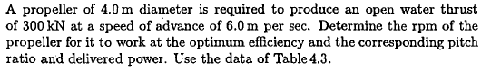
2-
D(m) | 4
T (kN) | 300
Va(m/s) | 6
N/rpm) | ?
P/D | ?
Pd(kW) | ?

Solution: The problem suits for the Case 1 which is “Optimum Rotation Rate for a Given Diameter” since thrust and diameter have been given.
The parameters given in the problem are to be used in this case is K_{t}/J² since in this parameter it does not contain the rotation rate:

Each column of table given above is scanned by calculating Eta0 and value of K_{t}/J² with Kt and Kq values. Then, an interpolation is performed for each column for data given in the problem as “0.508”. The performance data are obtained as shown right side of each column data.

P/D | 0.9
J | Kt | 10Kq | η0 | Kt/J^2 | 0.508
0.0 | 0.3840 | 0.4956 | 0.0000 | -
0.1 | 0.3567 | 0.4681 | 0.1213 | 35.6700
0.2 | 0.3263 | 0.4362 | 0.2381 | 8.1575
0.3 | 0.2929 | 0.3999 | 0.3497 | 3.2544
0.4 | 0.2564 | 0.3593 | 0.4543 | 1.6025 |  | eta0 | J | Kt | 10Kq
0.5 | 0.2169 | 0.3143 | 0.5492 | 0.8676 | 1 | 0.623408 | 0.593784 | 0.176948 | 0.267971
0.6 | 0.1743 | 0.2649 | 0.6283 | 0.4842 | 0
0.7 | 0.1287 | 0.2112 | 0.6789 | 0.2627
0.8 | 0.0800 | 0.1513 | 0.6732 | 0.1250
0.9 | 0.0283 | 0.0906 | 0.4474 | 0.0349

P/D | 1
J | Kt | 10Kq | η0 | Kt/J^4
0.0 | 0.4250 | 0.5994 | 0.0000 | -
0.1 | 0.3984 | 0.5698 | 0.1113 | 39.8400
0.2 | 0.3689 | 0.5357 | 0.2192 | 9.2225
0.3 | 0.3365 | 0.4971 | 0.3232 | 3.7389
0.4 | 0.3013 | 0.4540 | 0.4225 | 1.8831
0.5 | 0.2631 | 0.4064 | 0.5152 | 1.0524 |  | eta0 | J | Kt | 10Kq
0.6 | 0.2221 | 0.3543 | 0.5986 | 0.6169 | 1 | 0.628076 | 0.643015 | 0.203216 | 0.329911
0.7 | 0.1782 | 0.2976 | 0.6671 | 0.3637 | 0
0.8 | 0.1314 | 0.2365 | 0.7074 | 0.2053
0.9 | 0.0818 | 0.1708 | 0.6860 | 0.1010
1.0 | 0.0292 | 0.1007 | 0.4615 | 0.0292
P/D | 1.1
J | Kt | 10Kq | η0 | Kt/J^2
0.0 | 0.4644 | 0.7133 | 0.0000 | -
0.1 | 0.4391 | 0.6818 | 0.1025 | 43.9100
0.2 | 0.4109 | 0.6456 | 0.2026 | 10.2725
0.3 | 0.3799 | 0.6048 | 0.2999 | 4.2211
0.4 | 0.3461 | 0.5594 | 0.3939 | 2.1631
0.5 | 0.3095 | 0.5094 | 0.4835 | 1.2380 |  | eta0 | J | Kt | 10Kq
0.6 | 0.2701 | 0.4548 | 0.5671 | 0.7503 | 1 | 0.630428 | 0.684897 | 0.234189 | 0.404456
0.7 | 0.2278 | 0.3955 | 0.6417 | 0.4649 | 0
0.8 | 0.1827 | 0.3317 | 0.7013 | 0.2855
0.9 | 0.1348 | 0.2632 | 0.7336 | 0.1664
1.0 | 0.0841 | 0.1900 | 0.7045 | 0.0841
1.1 | 0.0305 | 0.1123 | 0.4755 | 0.0252

P/D | 1.2
J | Kt | 10Kq | η0 | Kt/J^2
0.0 | 0.5022 | 0.8374 | 0.0000 | -
0.1 | 0.4787 | 0.8040 | 0.0948 | 47.8700
0.2 | 0.4523 | 0.7659 | 0.1880 | 11.3075
0.3 | 0.4231 | 0.7231 | 0.2794 | 4.7011
0.4 | 0.3910 | 0.6757 | 0.3684 | 2.4438
0.5 | 0.3560 | 0.6234 | 0.4544 | 1.4240
0.6 | 0.3181 | 0.5665 | 0.5362 | 0.8836
0.7 | 0.2774 | 0.5049 | 0.6121 | 0.5661 |  | eta0 | J | Kt | 10Kq
0.8 | 0.2338 | 0.4385 | 0.6789 | 0.3653 | 1 | 0.62395 | 0.693481 | 0.283225 | 0.514129
0.9 | 0.1874 | 0.3675 | 0.7304 | 0.2314 | 0
1.0 | 0.1381 | 0.2917 | 0.7535 | 0.1381
1.1 | 0.0859 | 0.2113 | 0.7117 | 0.0710
1.2 | 0.0308 | 0.1261 | 0.4665 | 0.0214

P/D | 1.3
J | Kt | 10Kq | η0 | Kt/J^2
0.0 | 0.5384 | 0.9717 | 0.0000 | -
0.1 | 0.5173 | 0.9366 | 0.0879 | 51.7300
0.2 | 0.4931 | 0.8967 | 0.1750 | 12.3275
0.3 | 0.4959 | 0.8520 | 0.2779 | 5.5100
0.4 | 0.4358 | 0.8026 | 0.3457 | 2.7238
0.5 | 0.4026 | 0.7484 | 0.4281 | 1.6104
0.6 | 0.3663 | 0.6894 | 0.5074 | 1.0175 |  | eta0 | J | Kt | 10Kq
0.7 | 0.3271 | 0.6257 | 0.5824 | 0.6676 | 1 | 0.631516 | 0.771692 | 0.296774 | 0.576519
0.8 | 0.2848 | 0.5571 | 0.6509 | 0.4450 | 0
0.9 | 0.2396 | 0.4839 | 0.7092 | 0.2958
1.0 | 0.1913 | 0.4058 | 0.7503 | 0.1913
1.1 | 0.1400 | 0.3229 | 0.7591 | 0.1157
1.2 | 0.0857 | 0.2353 | 0.6956 | 0.0595
1.3 | 0.0284 | 0.1429 | 0.4112 | 0.0168

The column where the maximum efficiency obtained is selected. In this example maximum efficiency is obtained as 0.630 for the column P/D=1.1..
The latter is an easy procedure because J, Kt, and Kq values are known;

Alternatively you can use the program “PROPCALC” with the data given below
#..... OPTIMIZASYON SECENEGI INDISINI VE GEREKLI DEGERLERI GIRINIZ .......#
1
300. 4. 6.0 1025. 4. 0.5
T, D, VA, RHO, Z, AE

------------------------------------------------------------------------
! Program: PropCalc Versiyon: 10/12/2016 Dr. Ali Can TAKiNACI !
! !
! WAGENINGEN/GAWN SERISI PERVANE HIDRODINAMIK KARAKTERISTILERI !
! HESAP PROGRAMI !
------------------------------------------------------------------------

Pervane Karakteristikleri - Kt/J^2 = 0.508

i P/D J Kt 10Kq eta0 Bp delta
---|-------|-------|--------|--------|--------|------------|---------|
1 0.500 0.390 0.0773 0.0957 0.5010 34.0704 259.6974
2 0.510 0.396 0.0795 0.0985 0.5082 33.3434 255.9797

41 0.900 0.595 0.1796 0.2760 0.6158 20.1554 170.3192
42 0.910 0.599 0.1824 0.2823 0.6159 19.9998 169.0270

43 0.920 0.604 0.1851 0.2887 0.6160 19.8485 167.7616

44 0.930 0.608 0.1879 0.2952 0.6161 19.7014 166.5225
45 0.940 0.613 0.1907 0.3018 0.6160 19.5582 165.3085
88 1.370 0.782 0.3106 0.6528 0.5920 15.6320 129.5260
89 1.380 0.785 0.3134 0.6620 0.5916 15.5681 128.9514
90 1.390 0.789 0.3161 0.6712 0.5913 15.5047 128.3845
91 1.400 0.792 0.3189 0.6805 0.5909 15.4415 127.8250
---|-------|-------|--------|--------|--------|----- ------|-----------|

HESAPLARDA WAGENINGEN B SERISI KULLANILMISTIR

SECILEN PERVANE = 43. PERVANEDIR

P/D=0.920
J= 0.604 Kt= 0.185 10Kq= 0.289 eta= 0.616
Bp= 19.8485 delta= 167.7616
T= 300.00 kN Va= 6.000 m/s RHO = 1025.0 kg/m3
Z = 4. EAR = 0.500 D = 4.000 m
Vtip= 31.23 m/s
RPS= 2.485 dev/san RPM= 149.10 TORK= 187.143 kNm Pd= 2922.0 kW

TAM OLCEGE EKSTRAPOLASYONDA
VISKOZ DUZELTME YAPILMAMISTIR
-----------------------------------------------------------------|

As it was in the previous example the output is different since the performance data are different.

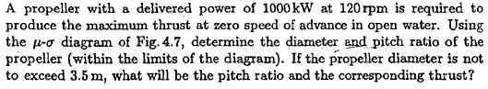
3-

This question is typical Bollard Pull problem. Instead of using µ- σ-φ diagrams, The program “PROPCALC” is to be run with the data given below,
#..... OPTIMIZASYON SECENEGI INDISINI VE GEREKLI DEGERLERI GIRINIZ .......#
4
1000. 120. 1025. 4 .50 3.3 3.4 3.5
DHP, RPM, RHO, Z, AE, D1, D2, D3

One obtains,
------------------------------------------------------------------------
! Program: PropCalc Versiyon: 10/12/2016 Dr. Ali Can TAKiNACI !
! !
! WAGENINGEN/GAWN SERISI PERVANE HIDRODINAMIK KARAKTERISTILERI !
! HESAP PROGRAMI !
------------------------------------------------------------------------

Pervane Karakteristikleri
---|-------|--------|-------|--------|---------|
i D 10Kq P/D Kt T(N)
---|-------|--------|-------|--------|---------|
1 3.300 0.4957 0.911 0.3783 183940.
2 3.400 0.4270 0.840 0.3492 191305.
3 3.500 0.3692 0.775 0.3219 198036.
---|-------|--------|-------|--------|---------|

HESAPLARDA WAGENINGEN B SERISI KULLANILMISTIR

SECILEN PERVANE =
P/D=0.775 Kt= 0.322 10Kq= 0.369
RPS= 2.000 RPM=120.000 T= 198.036 kN D= 3.500 m
Z= 4 EAR=0.500
RHO = 1025.0 kg/m3
TORK= 79.504 kNm Pd= 999.1 kW

TAM OLCEGE EKSTRAPOLASYONDA
VISKOZ DUZELTME YAPILMAMISTIR
-----------------------------------------------------------------|

