**PROPELLER THEORY – APPLICATIONS**

**1-**

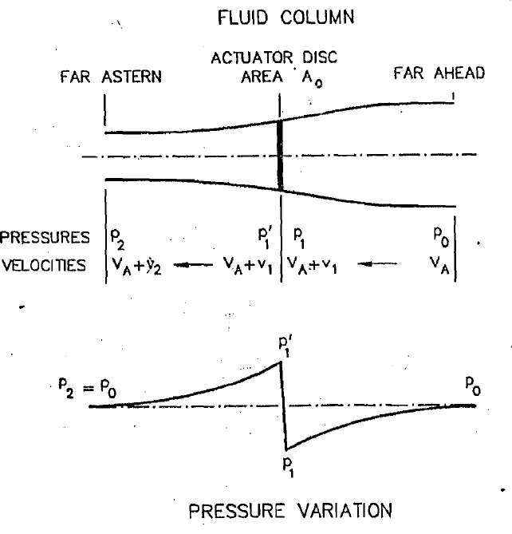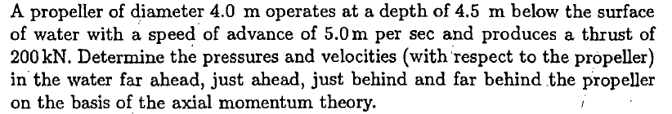

D = 4 m (diameter)

h= 4.5 (depht)

VA= 5 m/s (advance speed)

T = 200 Kn (Thrust)

P0 = Patm + Ph

Ph = ρgh = 1025*9.81*4.5=45248.6 N/m2

Patm=105 N/m2

P0 = 105 + 45248.6 = 145249 Pa (N/m2)

P2 = P0

Propeller Disc Area

T = (P1’- P0) A0 ==> 200000 = (P1’- P0)*12.56 🡺 (P1’- P0) = 15924 Pa

(P1’- P0) = ρ (VA + 1/2v2) v2 🡺 15924 = 1025*(5 + 0.5* v2) v2



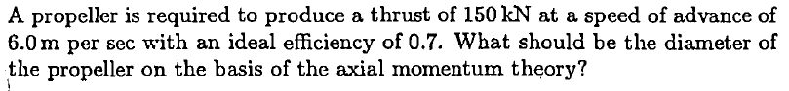

**2-**

T = 150 kN (thrust)

VA = 6 m/s (advance speed)

ηi = 0.7 (ideal efficiency)

D = ?? (diameter)





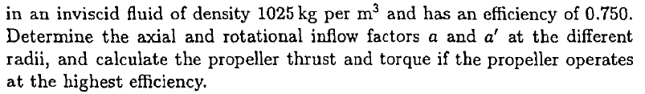

**3-**

|  |  |  |
| --- | --- | --- |
| D= | 5 | m |
| VA= | 6 | m/s |
| N= | 120 | RPM |
|  = | 1025 | kg/m3 |
| = | 0.75 |  |
|  |  |  |
| =2n= | 12.56637 | rad/s |

|  |  |  |  |  |  |  |  |  |  |  |
| --- | --- | --- | --- | --- | --- | --- | --- | --- | --- | --- |
| **r/R** | **r** | **VA2/( r)2** | **a/a'** | **a** | **a'** | **dT/dr** | **dQ/dr** | **SM** | **T*SM** | **Q*SM** |
| **(-)** | **(m)** |  |  |  |  | **(kN/m)** | **(kNm/m)** | **(-)** | **(kN/m)** | **(kNm/m)** |
| 0.2 | 0.50 | 0.91 | 0.82 | 0.333 | 0.405 | 103.0 | 65.6 | 1 | 103.0 | 65.6 |
| 0.3 | 0.75 | 0.41 | 1.85 | 0.333 | 0.180 | 154.6 | 98.4 | 4 | 618.3 | 393.6 |
| 0.4 | 1.00 | 0.23 | 3.29 | 0.333 | 0.101 | 206.1 | 131.2 | 2 | 412.2 | 262.4 |
| 0.5 | 1.25 | 0.15 | 5.14 | 0.333 | 0.065 | 257.6 | 164.0 | 4 | 1030.4 | 656.0 |
| 0.6 | 1.50 | 0.10 | 7.40 | 0.333 | 0.045 | 309.1 | 196.8 | 2 | 618.3 | 393.6 |
| 0.7 | 1.75 | 0.07 | 10.08 | 0.333 | 0.033 | 360.7 | 229.6 | 4 | 1442.6 | 918.4 |
| 0.8 | 2.00 | 0.06 | 13.16 | 0.333 | 0.025 | 412.2 | 262.4 | 2 | 824.4 | 524.8 |
| 0.9 | 2.25 | 0.05 | 16.65 | 0.333 | 0.020 | 463.7 | 295.2 | 4 | 1854.8 | 1180.8 |
| 1.0 | 2.50 | 0.04 | 20.56 | 0.333 | 0.016 | 515.2 | 328.0 | 1 | 515.2 | 328.0 |
|  |  |  |  |  |  |  |  |  | 7419.2 | 4723.2 |



|  |  |  |
| --- | --- | --- |
| h= | 0.25 |  |
| T= | 618.27 | kN, |
| Q= | 393.60 | kNm, |
|   = | 0.75 |  |
| PD= | 4946 | kW |

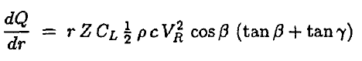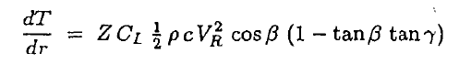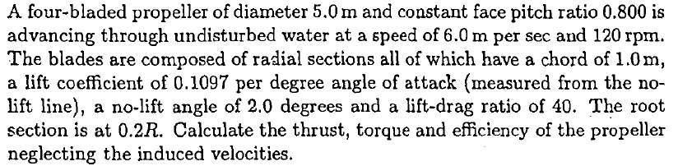

**4-**

|  |  |  |  |
| --- | --- | --- | --- |
| Z= | 4 |  |  |
| P/D= | 0.8 |  |  |
| D= | 5 | m |  |
| VA= | 6 | m/s |  |
| N= | 120 | RPM |  |
|  = | 1025 | kg/m3 |  |
|  = | 2 | degrees | zero lift angle |
| CL/CD= | 40 |  |  |
| dCL/d= | 0.1097 |  |  |
|  |  | |  | | --- | |  | |  |
| =2n= | 12.56637 | rad/s |  |

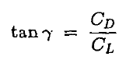

|  |  |  |  |  |  |  |  |  |
| --- | --- | --- | --- | --- | --- | --- | --- | --- |
| **r/R** | **r** | **tan** | **** | **tan** | **** | **cos** | **** | **CL** |
| **(-)** | **(m)** |  | **(deg)** |  | **(deg)** |  | **(deg)** |  |
| 0.2 | 0.50 | 1.27 | 51.85 | 0.955 | 43.68 | 0.723 | 8.17 | 1.12 |
| 0.3 | 0.75 | 0.85 | 40.33 | 0.637 | 32.48 | 0.844 | 7.84 | 1.08 |
| 0.4 | 1.00 | 0.64 | 32.48 | 0.477 | 25.52 | 0.902 | 6.96 | 0.98 |
| 0.5 | 1.25 | 0.51 | 26.99 | 0.382 | 20.91 | 0.934 | 6.08 | 0.89 |
| 0.6 | 1.50 | 0.42 | 23.00 | 0.318 | 17.66 | 0.953 | 5.34 | 0.81 |
| 0.7 | 1.75 | 0.36 | 19.99 | 0.273 | 15.26 | 0.965 | 4.73 | 0.74 |
| 0.8 | 2.00 | 0.32 | 17.66 | 0.239 | 13.43 | 0.973 | 4.23 | 0.68 |
| 0.9 | 2.25 | 0.28 | 15.80 | 0.212 | 11.98 | 0.978 | 3.82 | 0.64 |
| 1.0 | 2.50 | 0.25 | 14.29 | 0.191 | 10.81 | 0.982 | 3.47 | 0.60 |

|  |  |  |  |  |  |  |
| --- | --- | --- | --- | --- | --- | --- |
| **VR2** | **c** | **dT/dr** | **dQ/dr** | **SM** | **T*SM** | **Q*SM** |
| **(m2/s2)** | **(m)** | **(kN/m)** | **(kNm/m)** | **(-)** | **(kN/m)** | **(kNm/m)** |
| 75.48 | 1.00 | 121.9 | 127.8 | 1 | 121.9 | 127.8 |
| 124.83 | 1.00 | 229.4 | 253.3 | 4 | 917.6 | 1013.1 |
| 193.91 | 1.00 | 348.3 | 393.3 | 2 | 696.7 | 786.6 |
| 282.74 | 1.00 | 475.6 | 543.0 | 4 | 1902.4 | 2171.9 |
| 391.31 | 1.00 | 610.6 | 701.4 | 2 | 1221.2 | 1402.8 |
| 519.61 | 1.00 | 753.5 | 868.7 | 4 | 3013.8 | 3474.9 |
| 667.65 | 1.00 | 904.4 | 1045.2 | 2 | 1808.7 | 2090.4 |
| 835.44 | 1.00 | 1063.5 | 1231.1 | 4 | 4254.1 | 4924.2 |
| 1022.96 | 1.00 | 1231.1 | 1426.5 | 1 | 1231.1 | 1426.5 |
|  |  |  |  |  | 15167.5 | 17418.3 |

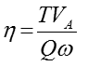

|  |  |  |  |  |
| --- | --- | --- | --- | --- |
| h= | 0.25 | m | SM interval | |
| T= | 1263.96 | kN, |  |  |
| Q= | 1451.52 | kNm, |  | |
|   = | 0.42 |  |
| PD= | 18240 | kW |
|  |  |  |