**PROPELLER DESIGN – APPLICATIONS**

**1-**

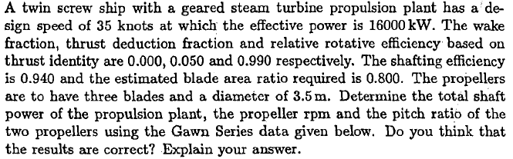

|  |  |  |
| --- | --- | --- |
| D(m) | 3.5 | Propeller Diameter |
| VS(knot) | 35 | Design Speed |
| AE/A0 | 0.8 | Expanded Area Ratio (Estimated) |
| PE(kW) | 16000 | Effective Power |
| N(RPM) | 150 | Cavitation Limit |
| w | 0.00 | Wake Fraction |
| t | 0.05 | Thrust Deduction |
| ηR | 0.99 | Rolative Rotative Efficency |
| ηS | 0.94 | Shafting Efficency |
| PB(kW) | ? | Total Power |
| P/D | ? | Pitch Ratio |
| N (RPM) | ? | Propeller RPM |

Advance Velocity;



Ship’s resistance;



Required Thrust per propeller;



Program is run with the following data (with Gawn Series of Propeller Option);

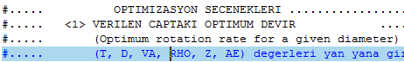



The following output is obtained

Pervane Karakteristikleri - Kt/J^2 = .115

i P/D J Kt 10Kq eta0 Bp delta

---|-------|-------|--------|--------|--------|------------|---------|

1 .500 .483 .0269 .0757 .2734 17.6962 209.4482

95 1.440 1.179 .1599 .4434 .6768 4.6112 85.8744

111 1.600 1.277 .1875 .5464 .6976 4.1939 79.2962

112 1.610 1.283 .1893 .5526 .6997 4.1679 78.9215

113 1.620 1.289 .1911 .5587 .7018 4.1419 78.5504

147 1.960 1.495 .2570 .6725 .9094 3.1377 67.7345

---|-------|-------|--------|--------|--------|----- ------|-----------|

P/D=1.610

J= 1.283 Kt= .189 10Kq= .553 eta= .700

Bp= 4.1679 delta= 78.9215

T= 467.80 kN Va= 18.000 m/s RHO = 1025.0 kg/m3

Z = 3. EAR = .800 D = 3.500 m

Vtip= 44.07 m/s

RPS= 4.008 dev/san RPM= 240.49 TORK= 477.876 kNm Pd=12034.6 kW

The trend of calculation is continuously increasing manner; so that the propeller is selected according to RPM constraint. The revolution rate is 240 RPM; the propeller efficiency is around 0.70.



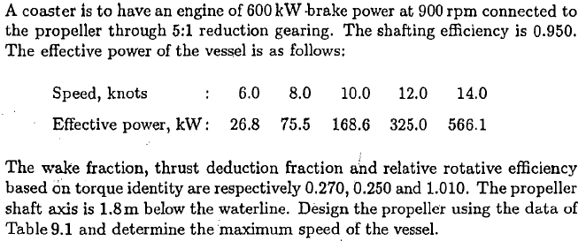

**2-**

|  |  |  |
| --- | --- | --- |
| VS(knots) | 20 | Speed |
| PME(kW) | 600 | Main Engine Power |
| NE(rpm) | 900 | Propeller Revolution Rate |
| i | 5:1 | Reduction gear ratio |
| w | 0.27 | Wake Fraction |
| t | 0.25 | Thrust Deduction |
| ηR | 1.01 | Rolative Rotative Efficency |
| ηS | 0.95 | Shafting Efficency |
| dS (m) | 1.8 | Shaft depht |
| AE/A0 | ? | Expanded Area Ratio |
| P/D | ? | Pitch to Diameter Ratio |
| D(m) | ? | Diameter |

Advance speeds of propeller for 12 and 14 knot,



Propeller rotation rate;



As the first trial program is run with the following data in order for determining the diameter which is major geometrical characteristic. For the speed, firstly, overall efficiency is guessed as 0.60 as reasonable estimation and multiply it with engine power (900 kW). One obtains 585 kW (=0.65*900) therefore, the speeds are determined as 12 and 14 knots respectively.

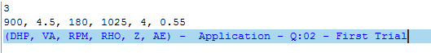Program is run for the speed of 12 knots with the following data 

The following output is obtained. The diameter D=3.087 m and pitch ratio P/D=0.72.

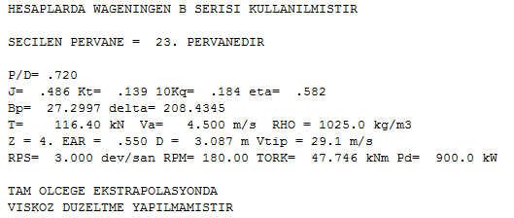

For the speed of 14 knots the same process is applied with the following data

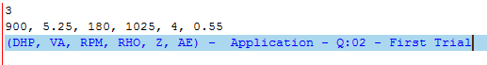

One obtains second output. The diameter is determined again as D=3.029 meters.

HESAPLARDA WAGENINGEN B SERISI KULLANILMISTIR

SECILEN PERVANE = 31. PERVANEDIR

P/D= .800

J= .578 Kt= .138 10Kq= .203 eta= .627

Bp= 18.5691 delta= 175.2980

T= 107.48 kN Va= 5.250 m/s RHO = 1025.0 kg/m3

Z = 4. EAR = .550 D = 3.029 m Vtip = 28.6 m/s

RPS= 3.000 dev/san RPM= 180.00 TORK= 47.746 kNm Pd= 900.0 kW

TAM OLCEGE EKSTRAPOLASYONDA

VISKOZ DUZELTME YAPILMAMISTIR

By noticing open water efficiencies 0.582 and 0.627 for the speeds of 12 and 14 knots respectively. As a result, a decision is made that that ship could be reach 14 knots of speed with the propeller having 3 meters in diameter.

The program is run with the Option 9 given below. This option contains cavitation check also

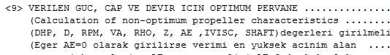

The data in this case (!!!Expanded area ratio is still 0.45)

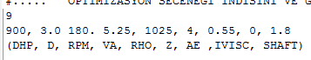

After run, the following partial output is obtained,

HESAPLARDA WAGENINGEN B SERISI KULLANILMISTIR

Z = 4 EAR = .550 P/D = .817

TORK= 47.746 kNm Pd= 900.0 kW

------------------------------------------------------------------------

BURRIL KAVITASYON KRITERINE GORE ACINIM ALANI KONTROLU

Mevcut EAR = .550 => Sigma = .550 Tauc = .146

%2.5 Sirt Kavitasyon Hattina Gore Min. EAR = .463

%5.0 Sirt Kavitasyon Hattina Gore Min. EAR = .383

Tavsiye edilen ust sinir icin Minimum EAR = .417

------------------------------------------------------------------------

KELLER KRITERINE GORE ACINIM ALANI KONTROLU

Min. EAR = .257 + k

EAR = .457 -> Tek pervaneli gemiler

EAR = .257 -> Hizli askeri gemiler (cift pervaneli.)

EAR = .357 -> Yavas ticari gemiler (cift pervaneli.)

------------------------------------------------------------------------

The expanded area ratios are obtained 0.417 according to Burril Criteria and 0.457 according to Keller’s Criteria (k=0.2), therefore final expanded area ration could be taken as the average of these two as 0.437 (=0.5*(0.457+0.417). Finally the program is run with this blade area ratio for the speed of 14 knots with the following data.



One obtains the following partial output as

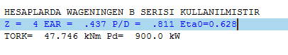

The open water efficiency is obtained as 0.628, therefore overall efficiency is



The engine power for the 14 knots of speed



The engine power is 900 kW which is greater than the required therefore the ship cannot be reach 14 knots of speed. The ship may reach 13.99 knots of speed. If the shafting efficiency was greater than 0.95 the speed goal can be achieved.

Or one may use 3 bladed propeller with the following data



The output is

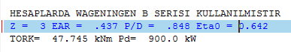

The same process gives



The engine power for the 14 knots of speed



**Three bladed propeller may satisfy the speed goal.**