**PROPELLER CAVITATION – APPLICATIONS**

**1-**

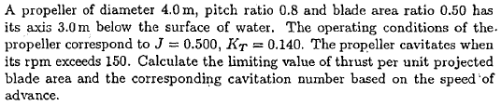

|  |  |  |
| --- | --- | --- |
| D(m) | 4 | Propeller Diameter |
| ds(m) | 3 | Shaft Depth |
| AE/A0 | 0.5 | Expanden Area Ratio Revolution |
| J | 0.5 | Advance Coefficient |
| KT | 0.14 | Thrust Coefficient |
| N(RPM) | 150 | Cavitation Limit |
| T/AP | ? | Limiting Value |
| σN | ? | Cavitation Number based on advance speed |

Shaft depth at Radius 0.7R;



Rotation rate;



Advance Velocity;



Reative Speed at radius 0.7R;

Cavitation Number based on relative speed at 0.7R radius;



Thrust Loading Coefficient τC,



Thrust per unit projected area,



Cavitation number based on advance speed at shaft center line,



Control:

Projection Area;



Thrust at operation conditions,



Limiting value of thrust,



Since Tlim=246 kN is much higher than actual thrust T=41.33 kN there is no cavitation risk.

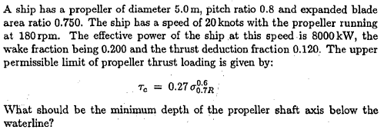

**2-**

|  |  |  |
| --- | --- | --- |
| VS(knots) | 20 | Speed |
| PE(kW) | 8000 | Brake Power |
| N(rpm) | 180 | Propeller Revolution Rate |
| AE/A0 | 0.75 | Expanded Area Ratio |
| P/D | 0.8 | Pitch to Diameter Ratio |
| w | 0.20 | Wake Fraction |
| t | 0.12 | Thrust Deduction |
| dS | ? | Shaft depht |

Advance speed of propeller,



Ship’s Resistance; (we need propeller thrust)



Propeller rotation rate;



Projection Area and Thrust per unit projection area,



Thrust loading coefficient;

Now we can calculate cavitation number form the relation given,



The relation for cavitation number,



The depth of Radius of 0.7R



Finally, the depyh of shaft center form loaded water line,



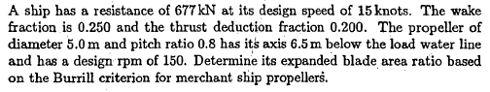

**3-**

|  |  |  |
| --- | --- | --- |
| VS(knots) | 15 | Speed |
| RT(kN) | 677 | Ship’s resistance |
| D(m) | 5 | Propeller Diameter |
| N(rpm) | 150 | Engine Revolution |
| w | 0.25 | Wake Fraction |
| t | 0.20 | Thrust Deduction |
| P/D | 0.8 | Pitch to Diameter Ratio |
| AE/A0 | ? | Expanded Area Ratio |

Advance speed of propeller,



Propeller thrust from ship’s resistance



Propeller rotation rate;



The depht 0.7R Radius from still water surface,



Relative speed at 0.7R Radius;



The relation for cavitation number,



Burrill’s Merchant ship’s upper limit criterion gives thrust loading coefficient;



Relation for thrust loading coefficient,



Projection Area,



Expanded area; 

Finally expanded area ratio;



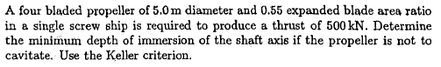

**4-**

|  |  |  |
| --- | --- | --- |
| Z | 4 | Number of Blade |
| T(kN) | 500 | Propeller thrust |
| D(m) | 5 | Propeller Diameter |
| N(rpm) | 150 | Engine Revolution |
| dS | ? | Shaft depht |
|  |  | Single screw propeller |

Advance speed of propeller,

