**PROPELLER BEHIND SHIP – APPLICATIONS**

**1-**

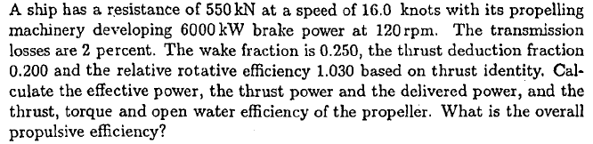

|  |  |  |
| --- | --- | --- |
| Rt(kN) | 550 | Ship’s Resistance |
| VS(knots) | 16 | Speed |
| N(rpm) | 120 | Engine Revolution |
| PB(kW) | 6000 | Brake Power |
| ηs | 0.98 | Shaft Efficency |
| w | 0.25 | Wake Fraction |
| t | 0.20 | Thrust Deduction |
| ηR | 1.03 | Thrust identity |
| PE(kW) | ? | Effective power |
| PT(kW) | ? | Thrust Power |
| T(kN) | ? | Thrust |
| Q(kN.m) | ? | Torque |
| η0 | ? | Open Water Efficency |
| ηD | ? | Overall Efficency |

Effective Power;



Thrust;



Torque;



Thrust Power;



Behind Efficiency;



Open Water Efficiency



Hull Efficiency



Overall Efficiency



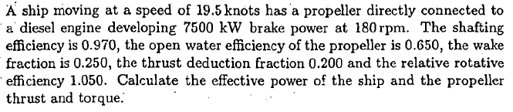

**2-**

|  |  |  |
| --- | --- | --- |
| VS(knots) | 19.5 | Speed |
| PB(kW) | 7500 | Brake Power |
| N(rpm) | 180 | Engine Revolution |
| ηs | 0.97 | Shaft Efficency |
| η0 | 0.65 | Open Water Efficency |
| w | 0.25 | Wake Fraction |
| t | 0.20 | Thrust Deduction |
| ηR | 1.03 | Thrust identity |
| PE(kW) | ? | Effective power |
| T(kN) | ? | Thrust |
| Q(kNn.m) | ? | Torque |

Hull Efficiency



Overall Efficiency



Delivered Power;



Effective Power;



Ship’s Resistance;



Propeller Thrust;



Propeller Torque;



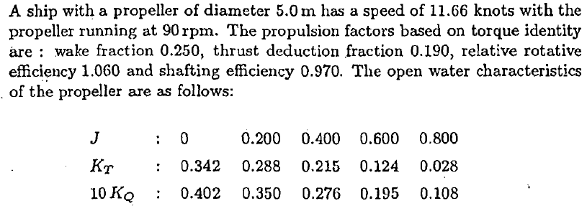

**3-**



|  |  |  |
| --- | --- | --- |
| VS(knots) | 11.66 | Speed |
| D(m) | 5 | Propeller Diameter |
| N(rpm) | 90 | Engine Revolution |
| ηs | 0.97 | Shaft Efficency |
| w | 0.25 | Wake Fraction |
| t | 0.19 | Thrust Deduction |
| ηR | 1.06 | Torque identity |
| PB(kW) | ? | Brake Power |
| PE(kW) | ? | Effective power |

Solution requires that



Propeller advance speed,



Propeller advance coefficient behind ship,



Behind ship efficiency of propeller,



Hull efficiency requires for overall efficiency calculation,



Overall efficiency except shaft loss (ηS)



Ship’s resistance computation needs thrust of propeller,



As last, brake power needs shaft loss;

