Architectural Theory and Modernism, Exam 2013

Name:

Please save your document as: YourName.doc
Return the exam until August 15th 18.00 to the address inceogl4@itu.edu.tr
Four questions are to be answered. Please try to use examples discussed in class as much as possible.

- Compare and discuss the concept of multiplicity in architecture and literature.

- We have discussed as a main characteristic of modernity to be ‘the dissolution of boundaries’. Please give examples of the dissolution of boundaries from architecture and music.

- Please compare in terms of similarities and differences the ‘Swan Lake’ and the ‘Rite of Spring’.

- Please compare the characteristics of Epic Theatre and architecture of Lucien Kroll.

- These are two very different works of art. However, they have similarities. Please show these similarities.
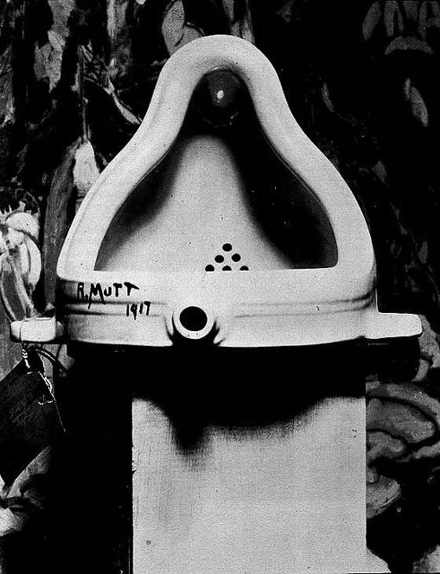
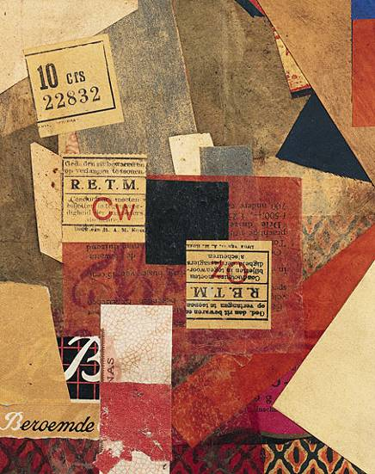

6. Please discuss the concept of fusion through examples from different fields given in class.

7. Control. Please discuss this concept within the context of all arts and architecture, through examples given in class.

