Connecting to VLSI Lab using NX Client:
- Download NX client and 4 fonts.
- Double click Install NX client and then follow the setup wizard to complete the installation.
- Install the font files in the given order (first install 75 dpi and install others last)
- Run NX client. Follow the wizard to complete installation.
Enter the following information when needed.
Session name is a random name you will choose
Host: nx.vls.itu.edu.tr
Port:22
Desktop: Unix GNOME
Note: You may select “Create shortcut on desktop” in the final dialog box before pressing Finish” for convenient use in the future.
- When you press finish the connection dialog box will open.
Type your ITU VLSI Lab user ID and password.
- Click “Configure” make sure “Remember my password” is selected and settings are correct as shown in figure:
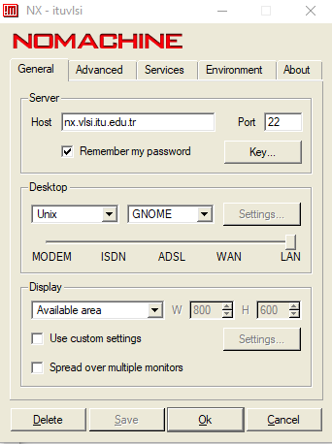
- When you click “Login”, the following window will appear only in the first time you bring up NX. Just click “Yes” and you will connect to the VLSI Labs server.
