[Title of the Report]

[Names of authors or authors]

[Name of the Related Course
The name of Advisor]
[Date]

[Title of Report]
[Summary]

[The summary should be about one page long. The summary should explain the outline of the study. Figures and tables should not be given in the summary.]

[Introduction]

[General information about the subject studied is given in the introduction section. This section contains the following information:
- Brief introduction of the subject (problem)
- Brief information about the previous studies on this subject (studies encountered during the literature review). Resources must be given here.
- General information about the study and its results
- In which sections the topics are explained in the report]

[Header 2]

[Header 3]

[Header 4]

[The figure text will be placed on the bottom of the figure, centered. Reference is made to the figure in the text, for example, as seen in Figure 1.1. The figure should be placed after the text is cited. The first part of the figure numbers should be the section number]

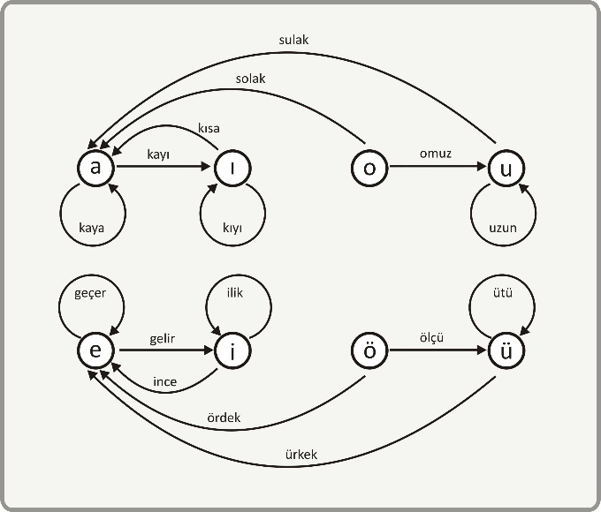
Figure-1.1: The outline of the project

[Introduction of the project]

[The definition of the realized project is made, and the detailed work plan created at the start of the project is given. In this plan, it is written which modules the project consists of, which stages (or modules) are planned to be carried out in which time frames, and if the project was carried out as a group, how to share among the group members.]

[Header 2]

[Header 3]

[Header 4]

[The table title will be centered on top of the table. Reference will be made to the table within the text, for example, as seen in Table 2.1. The table should be placed after the text is cited. The first part of the table numbers should be the section number]

Table-2.1: The result of Experiments
Name of the Experiments | System-1 | System -2 | System -3
Temperature | 13,45 | 14,5 | 16,77
Pressure | 123 | 122 | 135

[Theoretical Infrastructure]

[In this section, the theoretical information used in the realization of the project is given. These are generally theoretical information obtained during the research phase of the project. However, basic information that is widely known and easily found in the literature should not be written in detail. For example, there is no need to write details of an old programming language or operating system, catalog information of a microprocessor in this section. Instead, assignment should be made to relevant resources.

[Header 2]

[Header 3]

[Header 4]

[Analysis]

[Analysis and modeling, which is one of the development stages of the gene, will be explained in this subsection. In the analysis phase, the realworld components of the subject or problem and the relationships between these components are determined. The goal at this stage is to understand, not solve the problem.
Modeling, on the other hand, is a stage of the design and is oriented towards the solution of the subject or problem. At this stage; The "on paper" model of the hardware or software components to be created to realize the solution is created. Structural Analysis Model or UML can be used for software projects.]

[Header 2]

[Header 3]

[Header 4]

[Design, Realization and Testing]

[In this chapter; details of the created solution as software or hardware are explained. The components that make up the system are explained. Not all software source codes are included in the report. If there are software modules that are considered important or contain original contributions, relevant codes are written, and an explanation is made on them. Such program parts are included in the report as "Figures", are named and numbered. Source codes and other information about the project are delivered to the consultant on a storage medium.
Another issue to be explained in this section is the details of how the system is tested.]

[Header 2]

[Header 3]

[Header 4]

[Experiment results]

[The results obtained from the realized system will be included in this section with the necessary comments. If there are previous studies on similar subjects, the results should be compared with the results of these studies and the differences should be interpreted.]

[Header 2]

[Header 3]

[Header 4]

[Conclusion and Suggestions]

[The solution produced in the project will be interpreted by considering performance, price and environmental factors. Positive or negative aspects of the obtained results will be emphasized.
Suggestions should be given to those who will work in this field later in this section.]

[Header 2]

[Header 3]

[Header 4]

[References]

[References cited in the report, examples shown below should be written appropriately. For this purpose, the IEEE standard, which is given below, can be used. It should be noted that different formats are used for books, articles, conference papers and Internet addresses. ]

[1] E. Adalı, Mikroişlemciler Mikrobilgisayarlar, Birsen Yay. 1998.
[2] J. Daemon, V. Rijmen, The Design of Rijndal: AES the Advance Encryption Standard, Spring Science & Business Media, 2013
[3] C.K. Koç, About Cryptography Engineering in Cryptographic Engineering (pp: 1-4) Springer, Boston MA, 2009
[4] NIST Post-Quantum Cryptography Standardization Project, https://csrc.nits.gov/projects/post-quanrumcryptography, (acces time 21.10.2019)

