ARTICLE TITLE (13 points font)

**Author 11**File:ORCID iD.svg - Wikimedia Commons**, Author 22**File:ORCID iD.svg - Wikimedia Commons**, Author 31**File:ORCID iD.svg - Wikimedia Commons  
(ORCID link should be added to the image next to the author with a hyperlink.)

**1**Institution Name and Address

**2**Institution Name and Address

author1@itu.edu.tr, author2@mgm.gov.tr, author3@itu.edu.tr

Abstract

Abstract should be between 250-300 words and should be written here. Font size should be ***11 point Times New Roman***. This draft should be downloaded and continued when writing the text. The first page should not exceed one page. Font size can be reduced to 10.5 points font if necessary.

***Keywords:*** *First, Second, Third, Fourth, Fifth* (En az 3, en fazla 5 tane olmalı.)

TURKISH ARTICLE TITLE (13 point)

Özet

Turkish abstract should be between 250-300 words and should be written here. Font size should be ***11 point Times New Roman***. This draft should be downloaded and continued when writing the text. The first page should not exceed one page. Font size can be reduced to 10.5 points font if necessary.

***Anahtar Kelimeler:*** *Birinci, İkinci, Üçüncü, Dördüncü, Beşinci* (Minimum 3, maximum 5)

**Sorumlu Yazar:** Yazar 3

**Geliş Tarihi:** Gün Ay 2024 **Kabul Tarihi:** Gün Ay 2024 **Yayın Tarihi:** Gün Ay 2024

**Atıf Şekli:** Yazar1, Yazar 2, Yazar 3 (2024). Makale Başlığı, *Atmosfer ve İklim Dergisi,* X(X), X-X.

**Makale Tipi:** Araştırma Makalesi/Derleme **e-ISSN:** 3023-8560 (This section will be filled by the publisher.)

# INTRODUCTION

The introduction should be written in ***Times New Roman 12-points font*** without paragraph indentation. The space between lines should be set to 1. 1-line space should be left between paragraphs. The text should be selected as justified on both sides (Trenberth and Dai, 2003). When giving references in the text; if the reference has a single author (Author surname, 2024), if it has two authors (Author surname 1 and Author surname 2, 2023), if it has three or more authors (Author surname 1 et al., 2022).

**DATA AND WORK AREA (MAIN HEADINGS MUST BE IN 12 POINT SIZE AND ALL CAPITAL LETTERS)**

If there is no subheading after the main title, the text should begin without leaving any breaks.

# METHOD

**Data and Method (If there is a subheading under the main heading, there should be 6 pt space between them.**

There should be no space between the subheading and the text. If a figure or table is required within the text, there should be 1-line space between the figure or table and the text.

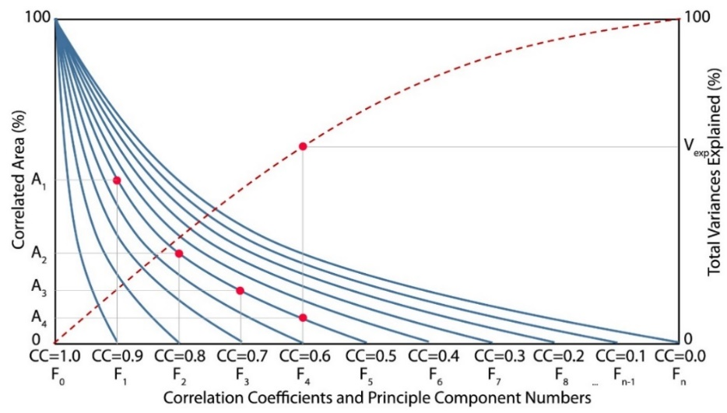

**Figure 1.** Figure captions should be written in 11-points font and centered. There should be a 3-pt space between the figure and the figure caption. There should be a 1-line space between the text following the figure and the figure caption.

# FINDINGS AND EVALUATIONS

Figures or tables should not be given immediately after the main title. Figures/tables must be given following at least two lines of text. The size of the figure/table must be proportional to the text.

**Table 1.** The table text should be 11 points font and the text inside the table should be 10 points font. There should be a 3 pt space between the table text and the table.

|  |  |  |
| --- | --- | --- |
| **Olasılık (%)** | **SPI** | **Kuraklık Sınıflandırması** |
| 2,30 | SPI≥2.00 | extreme wet |
| 4,40 | 2,00>SPI≥1,50 | very wet |
| 9,20 | 1,50>SPI≥1,00 | moderate wet |
| 68,20 | 1,00>SPI≥-1,00 | normal |
| 2,30 | -2,00≥SPI | extreme drought |

# RESULTS

The findings obtained throughout the article should be summarized under the main title Results. There should be no figures/tables. The entire article should not exceed 12 pages.

# ACKNOWLEDGEMENTS

This section should be added if preferred by the authors, it is not required to be included in the article.

REFERENCES

References should be written in APA format with Time New Roman 10-points font as seen in the examples below. Website addresses should not be in active view (blue-underlined). References should be in A-Z order from top to bottom by surname, each new source should start 0.25 in from the left. Website sources should be given as Web 1, Web 2 at the bottom and the date they were taken from the internet should be written in parentheses next to them.

Gadgil, S., P. N. Vinaychandran ve P. A. Francis (2003), Droughts of the Indian summer monsoon: Role of clouds over Indian Ocean, Curr. Sci., 85(12), 1713–1719.

Goswami, B. N., V. Venugopal, D. Sengupta, M. S. Madhusoodan ve P. K. Xavier (2006), Increasing trends of extreme rain events over India in a warming environment, Science, 314, 1442–1445, doi:10.1126/science.1132027.

Web 1, http://............., (16.01.2024 tarihinde alınmıştır).