Chapter Title
  - No Author Names to assist Blind Peer Review
  - Date

Abstract (500 words max)
Background and Aim: Please provide a background with the research need and the context and write the aim of your chapter.
Research Design and Methods: Please provide details of your methodological approach to achieve your research aim.
Findings: Please provide key findings.
Research Limitations: Every research has some limitations, please elaborate.
Theoretical Contribution: What is the contribution to knowledge?
Practical impact: How can businesses or other stakeholders exploit your results?
Keywords: Keyword 1; Keyword 2; Keyword 3 (up to five keywords)

Introduction
Context, research problem, motivation of authors, research aim and objectives. Please use UK English spelling consistently.

Literature Review
A state of the art literature review you conducted for your research. A summary table positioning your research within the existing body of literature is recommended.

A subsection
Use second and third level headings as appropriate. Subsections further than third level are not recommended.

Methods
Justifications for method choices. Where applicable, equations should be numbered and explained.

Findings
Findings presented using appropriate tables and figures. Please use the caption style provided. All tables and figures should be cross-referenced in the text. Please provide the source for the tables and figures as appropriate.
An example table is given in Table 1.
Table 1 An example table. Source: Authors

An example figure is given in Figure 1.
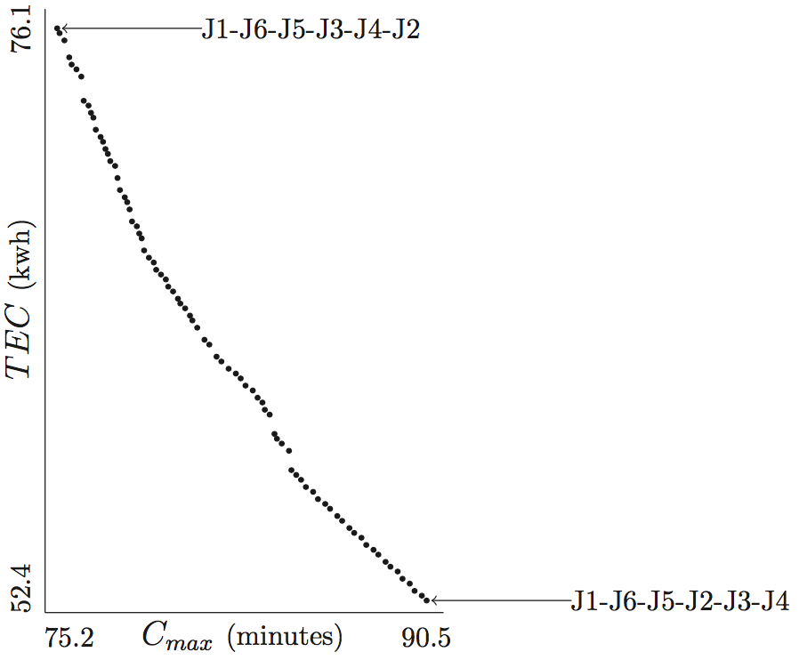
Figure 1 Pareto front of an example found using ε-constraint approach on CPLEX. Source: Mansouri, Aktas, & Besikci (2016), p. 776.
Figure 1 shows the Pareto optimal frontier proving that optimal completion time (Cmax) and total energy consumption (TEC) cannot be optimized simultaneously; therefore, a multi-objective optimisation approach must be adopted (Mansouri, Aktas, & Besikci, 2016).

Discussion
Linking findings back to the literature that informed the research and discussing similarities and differences with reasons why the authors think they reached such findings.

Conclusions
What is the new learning from this research? Theoretical and managerial implications. Future research suggestions. Recognition of limitations and ideas how they might be eliminated in the future.

References
Mansouri, S. A., Aktas, E., & Besikci, U. (2016). Green scheduling of a two-machine flowshop: Trade-off between makespan and energy consumption. European Journal of Operational Research, 248(3), 772–788. https://doi.org/10.1016/j.ejor.2015.08.064

Presented in APA Style 6th Edition. Cited in author-year format.
Any references to code repositories such as GitHub or data repositories such as FigShare are welcome.

Appendix
As appropriate. Data collection tool (e.g. survey questions), mathematical model, simulation code, proofs of theorems, or long tables could be included here.

